**Supporting Information**

**Title**

Authors listed here

*Affiliations listed here*

* E-mail: henri.xhaard@helsinki.fi. Tel. +358-2941-59190.

**Table of Contents**

**1. Structural and biological overview of all compounds (Figure S1)** 4

**2. Materials and general methods** 5

**4. NMR spectra for 5–15**, **22–24 and 26–28, ARW-220, ARW-222 More to be added…** 35

1H NMR of compound **5 (NJ1-20)** 35

13C NMR of compound **5 (NJ1-20)** 35

1H NMR of compound **6 (NJ1-35)** 36

13C NMR of compound **6 (NJ1-35)** 36

1H NMR of compound **7 (DAP-06)** 37

13C NMR of compound **7 (DAP-06)** 37

1H NMR of compound **8 (NJ1-31)** 38

13C NMR of compound **8 (NJ1-31)** 38

1H NMR of compound **9 (NJ1-39)** 39

13C NMR of compound **9 (NJ1-39)** 39

1H NMR of compound **10 (NJ1-19)** 40

13C NMR of compound **10 (NJ1-19)** 40

1H NMR of compound **11 (DAP-16)** 41

13C NMR of compound **11 (DAP-16)** 41

1H NMR of compound **12 (DAP-10b)** 42

13C NMR of compound **12 (DAP-10b)** 42

1H NMR of compound **13 (NJ1-27)** 43

13C NMR of compound **13 (NJ1-27)** 43

1H NMR of compound **14 (NJ1-26)** 44

13C NMR of compound **14 (NJ1-26)** 44

1H NMR of compound **15 (NJ1-24)** 45

13C NMR of compound **15 (NJ1-24)** 45

1H NMR of compound **22 (NJ1-32)** 46

13C NMR of compound **22 (NJ1-32)** 46

1H NMR of compound **XX** (ARW-220) 47

13C NMR of compound **XX** (ARW-220) 47

1H NMR of compound **23 (NJ1-87cont)** 48

13C NMR of compound **23 (NJ1-87cont)** 48

1H NMR of compound **24 (NJ1-53)** 49

13C NMR of compound **24 (NJ1-53)** 49

1H NMR of compound **26 (NJ1-58)** 50

13C NMR of compound **26 (NJ1-58)** 50

1H NMR of compound **27 (NJ1-59)** 51

13C NMR of compound **27 (NJ1-59)** 51

1H NMR of compound **XX** (ARW-222) 52

13C NMR of compound **XX** (ARW-222) 52

1H NMR of compound **28 (NJ1-71)** 53

13C NMR of compound **28 (NJ1-71)** 53

**6. Aggregation data for17, 26 and 27 (Figure S2)** 54

**7. KNIME workflow** 54

**X. References** 54

**STUFF** 55

5. Mass spectra for 5–15, 22–24 and 26–28 55

# **1. Structural and biological overview of all compounds (Figure S1)**

XXX

Figure S1: All compounds tested for this story (structures in 2D + pre-IC50)

# **2. Materials and general methods**

All chemicals used were commercially available. Reactions using anhydrous conditions were conducted in oven-dried (130 °C, >24 h) glassware and purged with argon prior to use. Microwave reactions were performed using a Biotage Initiator+ SP Wave Microwave Synthesizer (Uppsala, Sweden). The progress of the reactions was monitored by thin-layer chromatography on silica gel 60-F254 aluminum plates and visualized by using a dual short/long wave (254/366 nm) UV lamp. Combined organic solutions from extractions were dried over anhydrous Na2SO4, filtered and concentrated with a rotary evaporator at low pressure. Flash SiO2 column chromatography was performed with an automated high performance flash chromatography Biotage Isolera™ Spektra Systems with ACI™ and Assist (ISO-1SW Isolera One) equipped with a variable UV-VIS (200–800 nm) photodiode array (Uppsala, Sweden), SNAP KP-SIL or Ultra 10–25 g cartridges and the indicated mobile phase gradient. The reactions were not optimized and all the yields are given for purified products.

Characterization of the synthesized products were done by NMR and MS-analysis. 1H and 13C NMR spectra were acquired at 298 K on a Bruker Ascend 400 MHz – Avance III HD NMR spectrometer (Bruker Corporation, Billerica, MA, USA). Chemical shifts (*δ*) are reported in parts per million (ppm) relative to the residual NMR solvent signals (CDCl3: *δ*H = 7.26 and *δ*C = 77.16 ppm; CD3OD: *δ*H = 3.31 and *δ*C = 49.00 ppm; DMSO-*d*6: *δ*H = 2.50 and *δ*C = 39.52 ppm;) or the internal standard trimethylsilane, TMS (*δ*H = *δ*C = 0.00 ppm). Multiplicities are indicated as s (singlet), d (doublet), t (triplet), q (quartet), dd (doublet of doublets) and m (multiplet). Purity of the final compounds (>95%) was confirmed by LC-MS using a Waters Acquity® UPLC system (Waters, Milford, MA, USA) attached to an Acquity PDA detector and a Waters Synapt G2 HDMS mass spectrometer (Waters, Milford, MA, USA) equipped with an Acquity UPLC® BEH C18 column (1.7 μm, 50 × 2.1 mm, Waters, Ireland). Mass range was set from 100 to 600 Da. High resolution mass (HRMS-ESI) data was reported for the calculated and experimentally found molecular ions [M+H]+ or [M−H]−.

**3. Experimental procedures and characterization data**

The isoxazole core was constructed by three different routes (I–III), followed by hydrolysis (IV) to give isoxazole 3-carboxylic acids. Some compounds were also subsequently esterificied (V).

*General procedure I.* (**6**, **7**, **9**, **13**–**15**, **24**, **26**, **27**)

*General procedure II*. (**5**, **10**–**12**, **22**–**24**)

*General procedure III*. (**8**)

*General procedure IV*. (**5**–**9**, **14**, **22**–**24**)

*General procedure V*. (**26**–**28**)

------------------------------------------------------------------------------------------------------------------------

*Hydrolysis of compounds* ***5*–9**, **14** and **22–24** (*General procedure IV).* A round-bottomed flask was loaded with the isoxazole ester (1 equiv) and lithium hydroxide (2–4 equiv), followed by the addition of ethanol and water (2:1). The mixture was magnetically stirred at room temperature for 1–48 hours. The mixture was diluted with water (5–10 mL). Depending on the water solubility of the salts, the easily soluble ones were washed with EtOAc (3 × 5–15 mL) whereas the hardly water soluble salts were not, before acidification using 1 M hydrochloric acid. The product was extracted with EtOAc (3 × 5–15 mL), dried with Na2SO4, evaporated and was dried *in vacuo* overnight.

*Claisen condensation of compounds* ***10–12*** *(General procedure IIAB*).

*[3 + 2]**Cycloaddition of compounds* ***13*** *and* ***15****(General procedure I*). Ethyl-2-chloro-2-(hydroxymino)acetate (1.5–4 equiv), sodium bicarbonate (1.5–4 equiv), the appropriate alkyne (1 equiv, *solid/liquid* alkynes added *before/after* the solvent, respectively) and anhydrous acetonitrile (10–20 mL) were added to a 25 mL round-bottomed flask. The mixture was magnetically stirred at room temperature for several days. The resulting mixture was evaporated to dryness and subsequently purified by Biotage Isolera flash chromatography with TLC gradient estimation and a 10–25 g SNAP KP-Sil cartridge with hexane:ethyl acetate (1:0 → 0:1) as the eluent. This provided a yield of 57–100% of the obtained product as a whitish solid.

*Esterification of compounds* ***26****–****28*** *(General procedure V*). A round-bottomed flask was loaded with the acid (1 equiv). To the vial was dropwise added a solution of oxalyl chloride (1.1 equiv) in DCM (1 mL) and a catalytic amount of anhydrous DMF. The mixture was allowed to stir for 30 min before it was bubbled with argon for 5 min. The formed acid chloride was cooled to 0 °C in an ice bath. To the cooled solution was during 10 minutes added 2-bromophenol (1.1 equiv) in DCM (0.75 mL), followed by triethylamine (1.1 equiv) in DCM (0.75 mL). The mixture was stirred for 20 min in the ice bath and another 30 min at room temperature (1 h since the phenol addition). The solvent was evaporated and the residue was purified by Biotage Isolera flash chromatography with TLC gradient estimation and a 10 g SNAP KP-Sil cartridge with hexane:ethyl acetate (1:0 → 0:1) as the eluent. This provided 57–82% of the formed ester as a white solid.

**5-Phenylisoxazole-3-carboxylic acid (5).** Ethyl 5-phenylisoxazole-3-carboxylate (**10**) (11.5 mg, 0.053 mmol, 1 equiv) and lithium hydroxide (2.7 mg, 0.11 mmol, 2 equiv) with a 24 h reaction time gave **5** as a white solid (9.3 mg, 0.049 mmol, 93%). NJ1-20 1H NMR (400.15 MHz, MeOD) *δ* = 7.94 (s, 2H), 7.55 (s, 3H), 7.41 (s, 1H). 13C NMR (100.63 MHz, MeOD) *δ* = 170.8, 160.9, 157.9, 130.9, 129.3, 126.2, 125.8, 100.9. HRMS-ESI (*m*/*z*): calculated for C10H7NO3 [M+H]+ 190.0504; found, 190.0506.

**5-(3,5-Dimethylphenyl)isoxazole-3-carboxylic acid (6).** Ethyl 5-(3,5-dimethylphenyl)isoxazole-3-carboxylate (NJ1-30) (55.0 mg, 0.22 mmol, 1 equiv) and lithium hydroxide (11.1 mg, 0.46 mmol, 2 equiv) with a 16 h reaction time gave **6** as a white solid (43 mg, 0.20 mmol, 89%). NJ1-35 1H NMR (400.15 MHz, CDCl3) *δ* = 7.44 (s, 2H), 7.13 (s, 1H), 6.95 (s, 1H), 2.39 (s, 6H). 13C NMR (100.63 MHz, CDCl3) *δ* = 173.0, 163.1, 156.2, 139.1, 132.9, 126.3, 123.9, 100.0, 21.4. HRMS-ESI (*m*/*z*): calculated for C12H11NO3 [M+H]+,218.0817; found, 218.0817.

**5-(3-Carboxyphenyl)isoxazole-3-carboxylic acid (7).** Ethyl 5-(3-(methoxycarbonyl)phenyl)isoxazole-3-carboxylate (DAP-02) (22.8 mg, 0.083 mmol, 1 equiv) and lithium hydroxide (8.7 mg, 0.36 mmol, 4 equiv) with a 48 h reaction time gave **7** as a white solid (12 mg, 0.050 mmol, 60%). DAP-06 1H NMR (400.15 MHz, MeOD) *δ* = 8.50–8.48 (m, 1H), 8.17–8.08 (m, 2H), 7.68–7.62 (m, 1H), 7.23 (s, 1H). 13C NMR (100.63 MHz, MeOD) *δ* = 172.0, 168.6, 162.3, 159.1, 133.2, 132.8, 131.1, 130.7, 128.4, 127.9, 101.9. HRMS-ESI (*m*/*z*): calculated for C11H7NO5 [M+H]+ 234.0403; found, 234.0402. 

**5-(4-Cyanophenyl)isoxazole-3-carboxylic acid (8).** Ethyl 5-(4-cyanophenyl)isoxazole-3-carboxylate (NJ1-2&3) (12.6 mg, 0.052 mmol, 1 equiv) and lithium hydroxide (3.3 mg, 0.14 mmol, 3 equiv) with a 17 h reaction time gave **8** as a white solid (8.4 mg, 0.039 mmol, 75%). NJ1-31 1H NMR (400.15 MHz, MeOD) *δ* = 8.09–8.06 (m, 2H), 7.98–7.92 (m, 2H), 7.35 (s, 1H). 13C NMR (100.63 MHz, MeOD) *δ* = 170.9, 162.3, 159.4, 134.2, 131.9, 127.7, 119.0, 115.2, 103.5. HRMS-ESI (*m*/*z*): calculated for C11H6N2O3 [M+H]+ 215.0457; found, 215.0457.

**5-(3,5-Di-*tert*-butylphenyl)isoxazole-3-carboxylic acid (9).** Ethyl 5-(3,5-di-*tert*-butylphenyl)isoxazole-3-carboxylate (**13**) (14.0 mg, 0.043 mmol, 1 equiv) and lithium hydroxide (2.8 mg, 0.12 mmol, 3 equiv) with a 17 h reaction time gave **9** as a white solid (11 mg, 0.035 mmol, 89%). NJ1-33&39 1H NMR (400.15 MHz, CDCl3) *δ* = 10.6 (bs, 1H), 7.66 (d, *J* = 1.8 Hz, 2H), 7.58 (d, *J* = 1.8 Hz, 2H), 7.01 (s, 1H), 1.38 (s, 18H). 13C NMR (100.63 MHz, CDCl3) *δ* = 173.6, 164.3, 156.3, 152.1, 125.9, 125.5, 120.5, 100.0, 35.2, 31.5. HRMS-ESI (*m*/*z*): calculated for C18H23NO3 [M+H]+ 302.1756; found, 302.1757.

**Ethyl 5-phenylisoxazole-3-carboxylate (10).** General procedure II was used to give **10** as a white solid (81 mg, 82%).

**Ethyl 5-(3-methoxyphenyl)isoxazole-3-carboxylate (11).** General procedure II was used to give **11** as a white solid (43 mg, 89%).

**Ethyl 5-(4-methoxyphenyl)isoxazole-3-carboxylate (12).** General procedure II was used to give **12** as a white solid (43 mg, 89%).

**Ethyl 5-(3,5-di-*tert*-butylphenyl)isoxazole-3-carboxylate (13).** General procedure I was used to give **13** as a colorless oil (129 mg, 92%).

**5,5'-(1,3-Phenylene)bis(isoxazole-3-carboxylic acid) (14).** D iethyl 5,5'-(1,3-phenylene)bis(isoxazole-3-carboxylate) (**15**) (100 mg, 0.28 mmol, 1 equiv) and lithium hydroxide (27 mg, 1.1 mmol, 4 equiv) with a 20 h reaction time gave **14** as a pale yellow solid (77 mg, 0.26 mmol, 90%). NJ1-26 1H NMR (400.15 MHz, DMSO-*d6*) *δ* = 8.52 (s, 1H), 8.07 (d, *J* = 7.6 Hz, 2H), 7.73 (t, *J* = 7.6 Hz, 1H), 7.61 (s, 1H). 13C NMR (100.63 MHz, DMSO-*d6*) *δ* = 169.8, 160.7, 157.9, 130.5, 127.5, 127.3, 123.3, 102.0. HRMS-ESI (*m*/*z*): calculated for C14H8N2O6 [M+H]+ 301.0461; found, 301.0458.

**5-(2-methylthiazol-4-yl)isoxazole-3-carboxylic acid (17).** Purchased from Sigma (*CDS018284*). MTI61 1H NMR (400.15 MHz, DMSO-*d6*) *δ* =. 13C NMR (100.63 MHz, DMSO-*d6*) *δ* = . HRMS-ESI (*m*/*z*): calculated for C8H6N2O3S [M+H]+ 211.0177; found, 211.0179.

**Diethyl 5,5'-(1,3-phenylene)bis(isoxazole-3-carboxylate) (15).** General procedure I was used to give **15** as a white solid (568 mg, 100%).

**5-Phenyl-1*H*-pyrazole-3-carboxylic acid (22).** Ethyl 5-phenyl-1*H*-pyrazole-3-carboxylate (NJ1-21) (12.9 mg, 0.060 mmol, 1 equiv) and lithium hydroxide (3.9 mg, 0.16 mmol, 3 equiv) with a 19 h reaction time gave **22** as a white solid (8.9 mg, 0.047 mmol, 79%). NJ1-32 1H NMR (400.15 MHz, MeOD) *δ* = 7.78–7.73 (m, 2H), 7.47–7.41 (m, 2H), 7.39–7.34 (m, 1H), 7.12 (s, 1H). 13C NMR (100.63 MHz, MeOD) *δ* = 164.2, 149.3*, 142.5*, 131.8, 130.0, 129.6, 126.7, 106.1. *Verified by HMBC. HRMS-ESI (*m*/*z*): calculated for C12H12N2O2 [M+H]+ 217.0977; found, 217.0977.

**2-phenyl-1,3-thiazole-5-carboxylic acid (XX, ARW-220).** To a stirred suspension of methyl 2-bromothiazole-5-carboxylate (0.500 g, 2.25 mmol), phenylboronic acid (0.412 g, 3.38 mmol and tetrakis (triphenylphosphine) palladium 0 (0.260 g, 0.23 mmol) in dimethylformamide (10 mL) was added 2 M Na2CO3(aq) (4.73 mL, 9.46 mmol) and the reaction was stirred at 85 °C for 18 h. The reaction mixture was then filtered through Celite® and washed with water (20 mL) and 1 M NaOH(aq) (20 mL). The aqueous solution was washed with dichloromethane (2 × 50 mL), chloroform (2 × 50 mL) and ethyl acetate (50 mL) before being concentrated in vacuo to a volume of ~ 20 mL. The aqueous solution was acidified to pH 2 using concentrated hydrochloric acid and the resulting solid was collected by vacuum filtration to give a colourless solid (0.350 mg, 71%). 1H NMR δH (400 MHz, MeOD): 7.51 (s, 1H, H-3), 7.18 (app d, J = 7.7 Hz, 2H, H6), 6.86-6.43 (app m, 3H, H-7 & 8). 13C NMR δC (400 MHz, MeOD): 172.7, 163.9, 147.5, 132.8, 130.8, 128.9 128.9, 126.4 HRMS-ESI (*m*/*z*): calculated for C10H7NO2S [M+H]+: 205.0197, found: [M+H]+ 206.0221.

**5-(4-Nitrophenyl)-1*H*-pyrazole-3-carboxylic acid (23).** IIAC

General procedure IV was used to give **23** as a white solid (107 mg, 83%).

Ethyl 5-(4-nitrophenyl)-1*H*-pyrazole-3-carboxylate (NJ1-76) (150 mg, 0.57 mmol, 1 equiv) and lithium hydroxide (31.0 mg, 1.3 mmol, 2 equiv) with a 4.5 h reaction time gave after work-up mainly back the ester and some formed product. In the second attempt, the recovered crude (144 mg, 0.55 mmol, 1 eq) and lithium hydroxide (67.4 mg, 2.8 mmol, 5 equiv) with a 87 h reaction time gave **23** as a white solid (107 mg, 0.046 mmol, 83%). NJ1-87cont 1H NMR (400.15 MHz, DMSO-*d6*) *δ* = 8.34–8.22 (m, 2H), 8.21–8.08 (m, 2H), 7.45 (s, 1H). 13C NMR (100.63 MHz, DMSO-*d6*) *δ* = 166.2*, 162.2*, 146.8*, 143.3*, 126.2, 124.3, 107.0. *Verified by HMBC. HRMS-ESI (*m*/*z*): calculated for C12H11N3O4 [M–H]– 232.0358; found, 232.0358.

**5-(4-Nitrophenyl)isoxazole-3-carboxylic acid (24).** Ethyl 5-(4-nitrophenyl)isoxazole-3-carboxylate (DAP-22) (8.8 mg, 0.034 mmol, 1 equiv) and lithium hydroxide (1.9 mg, 0.079 mmol, 2 equiv) with a 1 h reaction time gave **24** as a white solid (5.1 mg, 0.022 mmol, 65%). NJ1-32 1H NMR (400.15 MHz, MeOD) *δ* = 8.42–8.38 (m, 2H), 8.18–8.13 (m, 2H), 7.38 (s, 1H). 13C NMR (100.63 MHz, MeOD) *δ* = 170.5, 162.5, 159.9, 150.3, 133.5, 128.1, 125.5, 103.9. *MeOH trace in proton, check NJ2-5*. HRMS-ESI (*m*/*z*): calculated for C10H6N2O5 [M–CO2–H]– 235.0355; found, 253.0357.

*OR*

Ethyl 5-(4-nitrophenyl)isoxazole-3-carboxylate (NJ2-4) (46.5 mg, 0.18 mmol, 1 equiv) and lithium hydroxide (11.2 mg, 0.47 mmol, 3 equiv) with a 1 h reaction time gave **24** as a white solid (41 mg, 0.18 mmol, 99%). NJ2-5 1H NMR (400.15 MHz, MeOD) *δ* = 8.42–8.38 (m, 2H), 8.18–8.13 (m, 2H), 7.40(s, 1H). 13C NMR (100.63 MHz, MeOD) *δ* = 170.5, 162.6, 159.9, 150.3, 133.5, 128.1, 125.5, 103.9. HRMS-ESI (*m*/*z*): calculated for C10H6N2O5 [M–CO2–H]– 235.0355; found, 253.0357. *– NO MS but more pure NMR*

**2-Bromophenyl 5-(3,5-dimethylphenyl)isoxazole-3-carboxylate (26).** I, IV

General procedure V was used to give **26** as a white solid (9.7 mg, 57%).

**2-Bromophenyl 5-(3,5-di-*tert*-butylphenyl)isoxazole-3-carboxylate (27).** I, IV

General procedure V was used to give **27** as a colorless oil that later on turned into a white solid (14 mg, 82%).

**2-Bromophenyl 5-(2-methylthiazol-4-yl)isoxazole-3-carboxylate (28).** General procedure V was used to give **28** as a white solid (99 mg, 57%).

**2-Bromophenyl 2-phenyl-1,3-thiazole-5-carboxylate (XX, ARW-222).** To a stirred solution of 2-phenyl-1,3-thiazole-5-carboxylic acid (0.150 g, 0.73 mmol) and EDC∙HCl (0.154 g, 0.80 mmol) in anhydrous dichloromethane (8 mL) was added 4-dimethylaminopyridine (0.098 g, 0.80 mmol) and 2-bromophenol (0.085 mL, 0.80 mmol) and catalytic anhydrous dimethylformamide (0.1 mL) and the reaction was stirred at RT for 18 h. The reaction mixture was then diluted with EtOAc (50 mL) and was washed with water (2 × 50 mL), dried with MgSO4 and concentrated in vacuo to afford the crude product as a yellow oil. Purification via flash column chromatography (eluent: 20% dichloromethane in petroleum ether) yielded the title compound as a colourless, crystalline solid (0.115 g, 44%). 1H NMR δH (400 MHz, MeOD): 8.81 (s, 1H, H-3), 8.11 (app d, J = 6.0 Hz, 2H, H6), 7.80 (app d, J = 7.9 Hz, 1H, H-3’), 7.64 – 7.49 (app m, 5H, H-7, 8, 5’ & 6’), 7.38 – 7.26 (app m, 1H, H-4’). 13C NMR δC (400 MHz, DMSO-*d6*): 174.3, 158.8, 151.6, 147.7, 133.7, 132.4, 132.4, 130.0, 129.7, 128.95, 127.42, 127.23, 124.83, 116.04. MS (ESI+) calculated for C16H10BrNO2S [M+H]+: 358.9616, found: 359.9614.

------------------------------------------------------------------------------------------------------------------------

**General procedure I (6, 7, 9, 13–15, 24**, **26, 27 +****MIDA boronate ester)**

**Scheme SX_I. General procedure of [3 + 2] cycloaddition reaction**



Ethyl-2-chloro-2-(hydroxymino)acetate (1.5–4 equiv), sodium bicarbonate (1.5–4 equiv), the appropriate alkyne (1 equiv, *solid/liquid* alkynes added *before/after* the solvent, respectively) and anhydrous acetonitrile (10–20 mL) were added to a 25 mL round-bottomed flask. The mixture was magnetically stirred at room temperature for several days. The resulting mixture was evaporated to dryness and subsequently purified by Biotage Isolera flash chromatography with TLC gradient estimation and a 10–25 g SNAP KP-Sil cartridge with hexane:ethyl acetate (1:0 → 0:1) as the eluent. This provided a yield of 57–100% of the obtained product as a whitish solid.

**General procedure II (5***B***, 10–12***AB***, 22–23***AC***, 24***AB***)**

**Scheme SX_II. General procedure for Claisen condensation and subsequent cyclization utilizing hydroxylamine or hydrazine**



**A) Claisen condensation.** Small pieces of sodium (1 equiv) were carefully added to a magnetically stirred solution of 99.5 wt-% ethanol (2–4 mL) in a 50–100 mL round-bottomed flask. When most of the sodium had reacted, anhydrous diethylether (20–50 mL) and diethyl oxalate (1 equiv) were added. To this solution was subsequently added arylketone (1 equiv) and the mixture was stirred at room temperature for 18 hours. The resulting mixture was extracted with three 10 mL portions of water or alternatively dissolved in 100 mL of water. The combined aqueous phases were acidified with concentrated acetic acid and the formed precipitate was filtered off and dried under reduced pressure. This provided 47–69% of the arylbutanoate product as a yellow or off-white solid that was used in the next step without further purifications..

**\*\*\*5 only?** A solution of acetophenone (1 equiv ) and diethyl oxalate (2 equiv) in ethanol (3 mL) was added to a freshly prepared solution of sodium ethoxide (5 mL, 2 equiv) at 50 °C. The mixture was stirred for 2 h at 80 °C before the solvent was evaporated. The remaining residue was stirred for 1 h in 1 M HCl (6mL), followed by extraction with EtOAc (3 × 10 mL). The crude product was washed with water (10 mL), dried with Na2SO4, evaporated and dried *in vacuo* overnight. The crude orange oil ethyl (E/Z)-2-hydroxy-4-oxo-4-phenylbut-2-enoatewas used in the next step without further purifications.

**B) Cyclization with hydroxylamine.** A 50 mL, two-necked, round-bottomed flask equipped with an argon inlet adapter, reflux condenser, and rubber septum was loaded with arylbutanoate (1 equiv) and hydroxylamine hydrochloride (1 equiv), and 99.5 wt-% ethanol (20 mL) was added via syringe. The solution was stirred at 80 °C for 3 hours. The solvent was evaporated and the residue was purified by Biotage Isolera flash chromatography with TLC gradient estimation and a 25 g SNAP KP-Sil cartridge with hexane:ethyl acetate (1:0 → 0:1) as the eluent. This provided 52–86% of the formed isoxazole as a white solid.

**C) Cyclization with hydrazine.** A 5 mL, round-bottomed flask was loaded with arylbutanoate (1 equiv) and 99.5 wt-% ethanol (2 mL), followed by addition of glacial acetic acid (1 equiv) and hydrazine hydrate (1 equiv). The solution was stirred at room temperature for 5 hours. The reaction mixture was diluted with 10 mL NaHCO3, extracted with EtOAc (3 × 15 mL), dried with Na2SO4, filtered, evaporated and the residue was purified by Biotage Isolera flash chromatography with TLC gradient estimation and a 10 g SNAP KP-Sil cartridge with hexane:ethyl acetate (1:0 → 0:1) as the eluent. This provided 82–86% of the formed pyrazole as a white solid.

**General procedure III (8, SXNJ1-52?)**

**Scheme SX_III. Suzuki coupling of MIDA-boronate functionalized isoxazoles**



The precursors for synthesizing compound **8** were made applying previously reported method (by Grob and co-workers).[REF]

NJ1-2&3…

**General procedure IV**

**Scheme SX_IV. Hydrolysis of esters (5–9, 14, 22–24)**



A round-bottomed flask was loaded with the isoxazole ester (1 equiv) and lithium hydroxide (2–4 equiv), followed by the addition of ethanol and water (2:1). The mixture was magnetically stirred at room temperature for 1–24 hours. The mixture was diluted with water (10 mL). Depending on the water solubility of the salts, the easily soluble ones were washed with EtOAc (3 × 15 mL) whereas the hardly water soluble salts were not, before acidification using 1 M hydrochloric acid. The product was extracted with EtOAc (3 × 10 mL), dried with Na2SO4, evaporated and the residue was dried *in vacuo* overnight.

**General procedure V**

**Scheme SX_V. Esterfication of acids (26, 27, 28)**



A 5 mL, round-bottomed flask was loaded with the acid (1 equiv). To the vial was dropwise added a solution of oxalyl chloride (1.1 equiv) in DCM (1 mL) and a catalytic amount of anhydrous DMF. The mixture was allowed to stir for 30 min before it was bubbled with argon for 5 min. The formed acid chloride was cooled to 0 °C in an ice bath. To the cooled solution was during 10 minutes added 2-bromophenol (1.1 equiv) in DCM (0.75 mL), followed by triethylamine (1.1 equiv) in DCM (0.75 mL). The mixture was stirred for 20 min in the ice bath and another 30 min at room temperature (1 h since the phenol addition). The solvent was evaporated and the residue was purified by Biotage Isolera flash chromatography with TLC gradient estimation and a 10 g SNAP KP-Sil cartridge with hexane:ethyl acetate (1:0 → 0:1) as the eluent. This provided 57–82% of the formed ester as a white solid.

-.-.-.-.-.-.-.-.-.-

**5-Phenylisoxazole-3-carboxylic acid (5).**

Acetophenone → ethyl-2-hydroxy-4-oxo-4-phenylbut-2-enoate → Ethyl 5-phenylisoxazole-3-carboxylate **(10)** → **5**

A solution of acetophenone (1 equiv) and diethyl oxalate (2 equiv) in ethanol (3 mL) was dropwise added to a freshly prepared solution of sodium ethoxide (5 mL, 2 equiv) at 50 °C. The mixture was stirred for 2 h at 80 °C and thereafter the solvent was evaporated. The remaining residue was stirred for 1 h in 1 M HCl (6mL), followed by extraction with EtOAc (3 × 10 mL). The crude product was washed with water (10 mL), dried with Na2SO4, filtered, evaporated and dried *in vacuo* overnight. The orange oil of ethyl (E/Z?)-2-hydroxy-4-oxo-4-phenylbut-2-enoate (**SX5-2**) was used as crude in the next step following General procedure IIB to give ethyl 5-phenylisoxazole-3-carboxylate (**SX5-1**).

General procedure IV was used to give **5** as a white solid (9.3 mg, 93%).

**5-(3,5-Dimethylphenyl)isoxazole-3-carboxylic acid (6).** *See synthesis of* ***26***

1-Ethynyl-3,5-dimethylbenzene → ethyl 5-(3,5-dimethylphenyl)isoxazole-3-carboxylate → **6**

**5-(3-Carboxyphenyl)isoxazole-3-carboxylic acid (7).**

Methyl 3-ethynylbenzoate → ethyl 5-(3-(methoxycarbonyl)phenyl)isoxazole-3-carboxylate → **7**

**5-(4-Cyanophenyl)isoxazole-3-carboxylic acid (8).**

4-Bromobenzonitrile → ethyl 5-(4-cyanophenyl)isoxazole-3-carboxylate → **8**

**5-(3,5-Di-*tert*-butylphenyl)isoxazole-3-carboxylic acid (9).** *See synthesis of* ***27***

1-Ethynyl-3,5-di-*tert*-butylbenzene → Ethyl 5-(3,5-di-*tert*-butylphenyl)isoxazole-3-carboxylate **(13)** → **9**

**Ethyl 5-phenylisoxazole-3-carboxylate (10).** *See synthesis of* ***5***

**Ethyl 5-(3-methoxyphenyl)isoxazole-3-carboxylate (11).**

3’-Methoxyacetophenone → ethyl 2-hydroxy-4-(3-methoxyphenyl)-4-oxobut-2-enoate → **11**

**Ethyl 5-(4-methoxyphenyl)isoxazole-3-carboxylate (12).**

4’-Methoxyacetophenone → ethyl 2-hydroxy-4-(4-methoxyphenyl)-4-oxobut-2-enoate → **12**

**Ethyl 5-(3,5-di-*tert*-butylphenyl)isoxazole-3-carboxylate (13).** *See synthesis of* ***9***

**5,5'-(1,3-Phenylene)bis(isoxazole-3-carboxylic acid) (14).**

1,3-Diethynylbenzene → diethyl 5,5'-(1,3-phenylene)bis(isoxazole-3-carboxylate) **(15)** → **14**

**Diethyl 5,5'-(1,3-phenylene)bis(isoxazole-3-carboxylate) (15).** *See synthesis of* ***14***

**5-Phenyl-1*H*-pyrazole-3-carboxylic acid (22).**

Acetophenone → ethyl-2-hydroxy-4-oxo-4-phenylbut-2-enoate → ethyl 5-phenyl-1*H*-pyrazole-3-carboxylate → **22**

**2-Phenyl-1,3-thiazole-5-carboxylic acid (ARW-220)**

To a stirred suspension of methyl 2-bromothiazole-5-carboxylate (0.500 g, 2.25 mmol), phenylboronic acid (0.412 g, 3.38 mmol and tetrakis (triphenylphosphine) palladium 0 (0.260 g, 0.23 mmol) in dimethylformamide (10 mL) was added 2 M Na2CO3(aq) (4.73 mL, 9.46 mmol) and the reaction was stirred at 85 °C for 18 h. The reaction mixture was then filtered through Celite® and washed with water (20 mL) and 1 M NaOH(aq) (20 mL). The aqueous solution was washed with dichloromethane (2 × 50 mL), chloroform (2 × 50 mL) and ethyl acetate (50 mL) before being concentrated in vacuo to a volume of ~ 20 mL. The aqueous solution was acidified to pH 2 using concentrated hydrochloric acid and the resulting solid was collected by vacuum filtration to give a colourless solid (0.350 mg, 71%). 1H NMR δH (400 MHz, MeOD): 7.51 (s, 1H, H-3), 7.18 (app d, J = 7.7 Hz, 2H, H6), 6.86-6.43 (app m, 3H, H-7 & 8). 13C NMR δC (400 MHz, MeOD): 172.7, 163.9, 147.5, 132.8, 130.8, 128.9 128.9, 126.4 HRMS-ESI (*m*/*z*): calculated for C10H7NO2S [M+H]+: 205.0197, found: [M+H]+ 206.0221.

**5-(4-Nitrophenyl)-1*H*-pyrazole-3-carboxylic acid (23).**

4-Nitroacetophenone → ethyl-2-hydroxy-4-(4-nitrophenyl)-4-oxobut-2-enoate → ethyl 5-(4-nitrophenyl)-1*H*-pyrazole-3-carboxylate → **23**

**5-(4-Nitrophenyl)isoxazole-3-carboxylic acid (24).**

4-Nitroacetophenone → ethyl-2-hydroxy-4-(4-nitrophenyl)-4-oxobut-2-enoate → ethyl 5-(4-nitrophenyl)isoxazole-3-carboxylate → **24**

**2-Bromophenyl 5-(3,5-dimethylphenyl)isoxazole-3-carboxylate (26).**

1-Ethynyl-3,5-dimethylbenzene → ethyl 5-(3,5-dimethylphenyl)isoxazole-3-carboxylate → 5-(3,5-Dimethylphenyl)isoxazole-3-carboxylic acid **(6)** → **26**

**2-Bromophenyl 5-(3,5-di-*tert*-butylphenyl)isoxazole-3-carboxylate (27).**

1-Ethynyl-3,5-di-*tert*-butylbenzene → Ethyl 5-(3,5-di-*tert*-butylphenyl)isoxazole-3-carboxylate **(13)** → 5-(3,5-Di-*tert*-butylphenyl)isoxazole-3-carboxylic acid **(9)** → **27**

**2-Bromophenyl 5-(2-methylthiazol-4-yl)isoxazole-3-carboxylate (28).**

5-(2-methylthiazol-4-yl)isoxazole-3-carboxylic acid **17** → **28**

**2-Bromophenyl 2-phenyl-1,3-thiazole-5-carboxylate (ARW-222).**

To a stirred solution of 2-phenyl-1,3-thiazole-5-carboxylic acid (0.150 g, 0.73 mmol) and EDC∙HCl (0.154 g, 0.80 mmol) in anhydrous dichloromethane (8 mL) was added 4-dimethylaminopyridine (0.098 g, 0.80 mmol) and 2-bromophenol (0.085 mL, 0.80 mmol) and catalytic anhydrous dimethylformamide (0.1 mL) and the reaction was stirred at RT for 18 h. The reaction mixture was then diluted with EtOAc (50 mL) and was washed with water (2 × 50 mL), dried with MgSO4 and concentrated in vacuo to afford the crude product as a yellow oil. Purification via flash column chromatography (eluent: 20% dichloromethane in petroleum ether) yielded the title compound as a colourless, crystalline solid (0.115 g, 44%). 1H NMR δH (400 MHz, MeOD): 8.81 (s, 1H, H-3), 8.11 (app d, J = 6.0 Hz, 2H, H6), 7.80 (app d, J = 7.9 Hz, 1H, H-3’), 7.64 – 7.49 (app m, 5H, H-7, 8, 5’ & 6’), 7.38 – 7.26 (app m, 1H, H-4’). 13C NMR δC (400 MHz, DMSO-*d6*): 174.3, 158.8, 151.6, 147.7, 133.7, 132.4, 132.4, 130.0, 129.7, 128.95, 127.42, 127.23, 124.83, 116.04. MS (ESI+) calculated for C16H10BrNO2S [M+H]+: 358.9616, found: 359.9614

**Ethyl 5-(2-(methoxycarbonyl)-4-nitrophenyl)isoxazole-3-carboxylate (NJ1-49)**

A 2–5 ml microwave vial equipped with a magnetic stirring bar was loaded with isoxazole MIDA-boronate (150 mg, 0.51 mmol, 1 equiv), methyl 2-bromo-5-nitrobenzoate (164 mg, 0.63 mmol, 1.2 equiv), X Phos Pd G2 (20.0 mg, 0.025 mmol, 0.05 equiv), Cu(OAc)2 (46.5 mg, 0.26 mmol, 0.5 equiv) and K2CO3 (492 mg, 3.6 mmol, 7 equiv). The microwave vial was capped and flushed three times with argon, followed by the addition of anhydrous acetonitrile (5.0 ml) and anhydrous *iso*-propanol (1.3 ml). In order to get rid of any trapped oxygen, the mixture was bubbled with argon for 10 min. The reaction mixture was irradiated in a variable voltage microwave instrument at 100 °C for 40 minutes. The resulting green mixture was filtered through a small pad of SiO2, evaporated and purified by a Biotage Isolera flash chromatography with TLC gradient estimation and a 25 g SNAP ultra cartridge with hexane:ethyl acetate (1:0 → 0:1) as the eluent. This provided 48.8 mg (0.15 mmol, 30%) of the bicyclic product as a white solid that was further recrystallized from ethanol.

**5-(4-cyanophenyl)isoxazole-3-carboxylic acid (8, NJ1-31)**



Synthesized according to the **general hydrolysis procedure** using NJ1-2&3 (12 mg, 0.050 mmol, 1 equiv) and lithium hydroxide (3.3 mg, 0.14 mmol, 3 equiv). The reaction time was 17 hours and the obtained yield was 78% (8,4 mg) of a white solid.

NJ1-31 1H NMR (400.15 MHz, MeOD) *δ* = 8.08 (d, 2H, *J*=8.7Hz), 7.90 (d, 2H, *J*=8.7Hz), 7.35 (s, 1H). 13C NMR (100.63 MHz, MeOD) *δ* = 170.9, 162.3, 159.4, 134.2, 131.9, 127.7, 119.0, 115.1, 103.5.

HRMS-ESI (*m*/*z*): calculated for C11H7N2O3 [M+H]+, 215.0457; found, 215.0457.



No ref values

**Diethyl 5,5'-(1,3-phenylene)bis(isoxazole-3-carboxylate) (15, NJ1-24)**



Synthesized according to the **ONESTEP procedure** using 1,3-diethynylbenzene (200 mg, 1.6 mmol, 1 equiv), ethyl-2-chloro-2-(hydroxyimino)acetate (721 mg, 4.8 mmol, 3 equiv) and sodium bicarbonate (401 mg, 4.8 mmol, 3 equiv). After 69 hours of the reaction time, more ethyl-2-chloro-2-(hydroxyimino)acetate (241 mg, 1.6 mmol, 1 equiv) and sodium bicarbonate (133 mg, 1.6 mmol, 1 equiv) were added. The total reaction time was 123 hours and a white solid product was obtained (568 mg, 1.6 mmol, 100% yield). M. p. XX–XX °C



1H NMR (400.15 MHz, CDCl3) *δ* = 8.25 (app t, *J* =1.5 Hz, 1H), 7.92 (dd, *J* =7.8, 1.7 Hz, 2H), 7.65 (app t, *J* =7.8 Hz, 1H), 7.05 (s, 1H), 4.50 (q, *J* =7.1 Hz, 2H), 1.46 (t, *J* =7.1 Hz, 3H). 13C NMR (100.63 MHz, CDCl3) *δ* = 170.5, 159.9, 157.3, 130.3, 128.1, 127.8, 123.4, 101.0, 62.6, 14.3. HRMS-ESI (*m*/*z*): calculated for C18H17N2O6 [M + H]+, 357.1087; found, 357.1091.



No ref values

**Ethyl 5-(3,5-di-*tert*-butylphenyl)isoxazole-3-carboxylate (13, NJ1-27)**



Synthesized according to the **ONESTEP procedure** using 1,3-di-*tert*-butyl-5-ethynylbenzene (91 mg, 0.42 mmol, 1 equiv), ethyl-2-chloro-2-(hydroxyimino)acetate (128 mg, 0.85 mmol, 2 equiv) and sodium bicarbonate (77 mg, 0.91 mmol, 2 equiv). The reaction time was 135 hours and the yield was 92% (129 mg, 0.39 mmol) of a white solid.



1H NMR (400.15 MHz, CDCl3) *δ* = 7.64 (d, *J* =1.8 Hz, 2H), 7.55 (app t, *J* = 1.8 Hz, 1H), 6.92 (s, 1H), 4.48 (q, *J* =7.1 Hz, 2H), 1.45 (t, *J* =7.1 Hz, 3H) 1.37 (s, 18H). 13C NMR (100.63 MHz, CDCl3) *δ* = 172.9, 160.3, 157.0, 152.0, 126.2, 125.3, 120.4, 99.8, 62.3, 35.2, 31.5, 14.4. HRMS-ESI (*m*/*z*): calculated for C20H28NO3 [M + H]+, 330.2069; found, 330.2068.



No ref values

**Ethyl 5-(3,5-dimethylphenyl)isoxazole-3-carboxylate (SM6, NJ1-30)**



Synthesized according to the **ONESTEP procedure** using 1-ethynyl-3,5-dimethylbenzene (106 mg, 0.81 mmol, 1 equiv), ethyl-2-chloro-2-(hydroxyimino)acetate (249 mg, 1.6 mmol, 2 equiv) and sodium bicarbonate (138 mg, 1.6 mmol, 2 equiv). The reaction time was 80 hours and the yield was 70% (140 mg, 0.57 mmol) of a white solid.

1H NMR (400.15 MHz, CDCl3) *δ* = 7.43 (s, 2H), 7.11 (s, 1H), 6.89 (s, 1H), 4.47 (q, *J* =7.1 Hz, 2H), 2.38 (s, 6H), 1.44 (t, *J* =7.1 Hz, 3H). 13C NMR (100.63 MHz, CDCl3) *δ* = 172.2, 160.3, 157.0, 139.0, 132.6, 126.6, 123.8, 99.9, 62.3, 21.4, 14.3. HRMS-ESI (*m*/*z*): calculated for C14H16NO3 [M + H]+, 246.1130; found, 246.1131.



No ref values

**Ethyl 5-(2-(methoxycarbonyl)phenyl)isoxazole-3-carboxylate (DAP-14)**



Synthesized according to the **ONESTEP procedure** using methyl 2-ethynylbenzoate (128 mg, 0.80 mmol, 1 equiv), ethyl-2-chloro-2-(hydroxyimino)acetate (241 mg, 1.6 mmol, 2 equiv) and sodium bicarbonate (152 mg, 1.8 mmol, 2 equiv). The reaction time was 136 hours and the yield was 59% (130 mg, 0.47 mmol) of a yellow oil that later on formed an off-white solid.



1H NMR (400.15 MHz, CDCl3) *δ* = 7.92–7.88 (m, 1 H), 7.64–7.60 (m, 2H), 7.60–7.54 (m, 1H), 6.87 (s, 1H), 4.47 (q, *J* = 7.1, 2H), 3.84 (s, 3H), 1.43 (t, *J* = 7.1 Hz, 3H). 13C NMR (100.63 MHz, CDCl3) *δ* = 170.9, 167.0, 159.7, 156.4, 131.7, 130.7, 130.5, 130.2, 129.8, 126.4, 103.1, 62.0, 52.5, 14.0. HRMS-ESI (*m*/*z*): calculated for C14H14NO5 [M + H]+, 276.0872; found, 276.0873.



No ref values

**Ethyl 5-(4-(methoxycarbonyl)phenyl)isoxazole-3-carboxylate (DAP-17)**



Synthesized according to the **ONESTEP procedure** using methyl 4-ethynylbenzoate (412 mg, 2.6 mmol, 1 equiv), ethyl-2-chloro-2-(hydroxyimino)acetate (584 mg, 3.9 mmol, 1.5 equiv) and sodium bicarbonate (363 mg, 4.3 mmol, 1.7 equiv). The reaction time was 120 hours and the yield was 57% (406 mg, 1.5 mmol) of an off-white solid.



1H NMR (400.15 MHz, CDCl3) *δ* = 8.18–8.14 (m, 2H), 7.91–7.87 (m, 2H), 7.03 (s, 1H), 4.49 (q, *J* = 7.2 Hz, 2H), 3.96 (s, 3H), 1.45 (t, *J* = 7.1 Hz, 3H). 13C NMR (100.63 MHz, CDCl3) *δ* = 170.6, 166.3, 159.9, 157.3, 132.1, 130.5, 130.4, 126.0, 101.5, 62.5, 52.6, 14.3. HRMS-ESI (*m*/*z*): calculated for C14H14NO5 [M+H]+, 276.0872; found, 276.0559. MS MISSING!



No ref values

R = *o*-OMe; *p*-NO2;



Scheme SX. Ketone route towards isoxazole 3-carboxylic acids

**TWOSTEP via ethyl 3-(aryl)-2,4-dioxobutanoates**/**ethyl 2,4-dioxo-4-arylbutanoate?**

**General procedures for the synthesis of compounds MTI-35, 49**

**General procedure for the synthesis of XXX-YYY via Claisen condensation and cyclization utilizing hydroxylamine**

**CHECK ORDER aryl vs diethyl**

**Claisen condensation.** Small pieces of sodium (1 equiv) were carefully added to a magnetically stirred solution of 99.5 wt-% ethanol (2–4 mL) in a 50–100 mL round-bottomed flask. When most of the sodium had reacted, anhydrous diethylether (20–50 mL) and diethyl oxalate (1 equiv) were added. To this solution was subsequently added arylketone (X.Y equiv) and the mixture was stirred at room temperature for 18 hours. The resulting mixture was extracted with three 10 mL portions of water or alternatively dissolved in 100 mL of water. The combined aqueous phases were acidified with concentrated acetic acid and the formed precipitate was filtered off and dried under reduced pressure. This provided 47–69% of the arylbutanoate product as a yellow or off-white solid.

**Cyclization with hydroxylamine.** A 50 mL, two-necked, round-bottomed flask equipped with an argon inlet adapter, reflux condenser, and rubber septum was loaded with arylbutanoate (1 equiv) and hydroxylamine hydrochloride (1 equiv), and 99.5 wt-% ethanol (20 mL) was added via syringe. The solution was stirred at 80 °C for 3 hours. The solvent was evaporated and the residue was purified by Biotage Isolera flash chromatography with TLC gradient estimation and a 25 g SNAP KP-Sil cartridge with hexane:ethyl acetate (1:0 → 0:1) as the eluent. This provided 52–86% of the formed isoxazole as a white solid.

**Ethyl (Z)-2-hydroxy-4-(2-methoxyphenyl)-4-oxobut-2-enoate (DAP-12)**



Synthesized according to the **TWOSTEP procedure 1)** using *m*-methoxyacetophenone (963 mg, 6.4 mmol, 1 equiv) and the obtained yield was 69% (1110 mg, 4.4 mmol) of a yellow solid.

50ml, 69%, pale yellow solid.



1H NMR (400.15 MHz, CDCl3) *δ* = 7.88 (dd, *J* = 7.8, 1.8 Hz, 1H), 7.51 (ddd, *J* = 8.4, 7.3, 1.8 Hz, 1H), 7.29 (s, 1H), 7.07–7.03 (m, 1H), 6.99 (app d, *J* = 8.4 Hz, 1H), 4.38 (q, *J* = 7.1 Hz, 2H), 3.94 (s, 3H), 1.40 (t, *J* = 7.1 Hz, 3H). 13C NMR (100.63 MHz, CDCl3) *δ* = 190.6, 169.1, 162.7, 159.3, 134.7, 130.9, 124.8, 121.0, 111.9, 103.2, 62.5, 55.9, 14.1.***OH not visible

HRMS-ESI (*m*/*z*): calculated for C13H15O5 [M+H]+, 357.1087; found, 357.1091. MS MISSING!



In accordance to lit. A. Tourteau et al. / Bioorg. Med. Chem. 21 (2013) 5383–5394

**Ethyl (E/Z?)-2-hydroxy-4-(4-nitrophenyl)-4-oxobut-2-enoate (DAP-15)**



Synthesized according to the **TWOSTEP procedure 1)** using *p*-nitroacetophenone (1970 mg, 12 mmol, 1 equiv) and the obtained yield was 47% (1450 mg, 5.6 mmol) of an off-white solid.

100 ml, *p*-nitroacetophenone (1972 mg), 47%, ?



1H NMR (400.15 MHz, CDCl3) *δ* = δ 8.38–8.32 (m, 2H), 8.18–8.12 (m, 2H), 7.10 (s, 1H), 4.42 (q, *J* = 7.1 Hz, 2H), 1.43 (t, *J* = 7.1 Hz, 3H). 13C NMR (100.63 MHz, CDCl3) *δ* = 186.9, 172.8, 161.7, 150.7, 139.9, 128.9, 124.2, 98.3, 63.1, 14.2.

***OH not visible

HRMS-ESI (*m*/*z*): calculated for C12H12NO6 [M +H]+, 357.1087; found, 357.1091. MS MISSING!



L. Nagarapu et al. / European Journal of Medicinal Chemistry 45 (2010) 4720–4725

**Ethyl 5-(2-methoxyphenyl)isoxazole-3-carboxylate (DAP-18)**



Synthesized according to the **TWOSTEP procedure 2)** using DAP-12 (505 mg, 2.0 mmol, 1 equiv) and

hydroxylamine hydrochloride (163 mg, 2.3 mmol, 1 equiv). The reaction time was 3.5 hours and the obtained yield was 86% (431 mg, 1.7 mmol) of a white solid.



1H NMR (400.15 MHz, CDCl3) *δ* = 8.00 (dd, *J* = 7.8, 1.7 Hz, 1H), 7.47–7.40 (m, 1H), 7.17 (s, 1H), 7.11–7.05 (m, 1H), 7.02 (app d, *J* = 8.4 Hz, 1H), 4.47 (q, *J* = 7.2 Hz, 2H), 3.98 (s, 3H), 1.44 (t, *J* = 7.1 Hz, 3H). 13C NMR (100.63 MHz, CDCl3) *δ* = 167.9, 160.6, 157.1, 156.4, 132.0, 127.8, 121.0, 115.8, 111.4, 104.0, 62.2, 55.7, 14.3.

HRMS-ESI (*m*/*z*): calculated for C13H14NO4 [M + H]+ 248.0923; found 248.0926.



REF A. Tourteau et al. / Bioorg. Med. Chem. 21 (2013) 5383–5394

**Ethyl 5-(4-nitrophenyl)isoxazole-3-carboxylate (SM24, DAP-22)**



Synthesized according to the **TWOSTEP procedure 2)** using DAP-15 (264 mg, 1.0 mmol, 1 equiv) and hydroxylamine hydrochloride (77 mg, 1.1 mmol, 1 equiv). The reaction time was 3 hours and the obtained yield was 52% (135 mg, 0.51 mmol) of a white solid.

SM left in DAP22, NJ redone ok?



1H NMR (400.15 MHz, CDCl3) *δ* = 8.39–8.34 (m, 2H), 8.02–7.97 (m, 2H), 7.11 (s, 1H), 4.49 (q, *J* = 7.1 Hz, 2H), 1.45 (t, *J* = 7.1 Hz, 3H). 13C NMR (100.63 MHz, CDCl3) *δ* = 169.2, 159.6, 157.4, 149.0, 132.0, 126.9, 124.7, 102.6, 62.7, 14.3.

HRMS-ESI (*m*/*z*): calculated for C12H11N2O5 [M + H]+, 263.0668; found, 263.0665. IMPURE!



J. Zhao et al. / Bioorg. Med. Chem. Lett. 24 (2014) 2802–2806

**Ethyl 5-(2-(methoxycarbonyl)-4-nitrophenyl)isoxazole-3-carboxylate (NJ1-49)**

A 2–5 ml microwave vial equipped with a magnetic stirring bar was loaded with isoxazole MIDA-boronate (150 mg, 0.51 mmol, 1 equiv), methyl 2-bromo-5-nitrobenzoate (164 mg, 0.63 mmol, 1.2 equiv), X Phos Pd G2 (20.0 mg, 0.025 mmol, 0.05 equiv), Cu(OAc)2 (46.5 mg, 0.26 mmol, 0.5 equiv) and K2CO3 (492 mg, 3.6 mmol, 7 equiv). The microwave vial was capped and flushed three times with argon, followed by the addition of anhydrous acetonitrile (5.0 ml) and anhydrous *iso*-propanol (1.3 ml). In order to get rid of any trapped oxygen, the mixture was bubbled with argon for 10 min. The reaction mixture was irradiated in a variable voltage microwave instrument at 100 °C for 40 minutes. The resulting green mixture was filtered through a small pad of SiO2, evaporated and purified by a Biotage Isolera flash chromatography with TLC gradient estimation and a 25 g SNAP ultra cartridge with hexane:ethyl acetate (1:0 → 0:1) as the eluent. This provided 48.8 mg (0.15 mmol, 30%) of the bicyclic product as a white solid that was further recrystallized from ethanol.



1H NMR (400.15 MHz, CDCl3) *δ* = 8.76 (d, *J* =2.2 Hz, 1H), 8.46 (dd, *J* =8.5, 2.4 Hz, 1H), 7.89 (d, *J* =8.5 Hz, 1H), 7.03 (s, 1H), 4.50 (q, *J* =7.1 Hz, 2H), 3.93 (s, 3H), 1.45 (t, *J* =7.1 Hz, 3H). 13C NMR (100.63 MHz, CDCl3) *δ* = 168.4, 165.3, 159.6, 157.0, 148.7, 132.3, 132.0, 131.3, 126.4, 125.7, 105.4, 62.6, 53.5, 14.3.

HRMS-ESI (*m*/*z*): calculated for C14H13N2O7 [M+H]+, 321.0723; found, 321.0722.



No ref values

**5,5'-(1,3-Phenylene)bis(isoxazole-3-carboxylic acid) (14, NJ1-26)**



5,6-2,6, 10, 3x15

Synthesized according to the **general hydrolysis procedure** using NJ1-24 (100 mg, 0.28 mmol, 1 equiv) and lithium hydroxide (27 mg, 1.1 mmol, 4equiv). The reaction time was 16 hours and the obtained yield was 91% (77 mg, 0.26 mmol) of an off-white solid.



1H NMR (400.15 MHz, DMSO-*d6*) *δ* = 8.52 (s, 1H), 8.07 (d, *J* = 7.4 Hz, 2H), 7.73 (app t, *J* = 7.6 Hz, 1H), 7.61 (s, 2H). 13C NMR (100.63 MHz, DMSO-*d6*) *δ* = 169.8, 160.7, 157.9, 130.5, 127.5, 127.3, 123.3, 102.0).

HRMS-ESI (*m*/*z*): calculated for C14H9N2O6 [M +H]+, 301.0461; found, 301.0458.



No ref values

**5-(3,5-Di-*tert*-butylphenyl)isoxazole-3-carboxylic acid (9, NJ1-33,39)**



8-2, 15, 3x15

Synthesized according to the **general hydrolysis procedure** using NJ1-27 (40 mg, 0.12 mmol, 1 equiv) and lithium hydroxide (6.4 mg, 0.27 mmol, 2equiv). The reaction time was 1 hour and the obtained yield was 100% (37 mg, 0.12 mmol) of a white solid.



NJ1-39 1H NMR (400.15 MHz, CDCl3) *δ* = 10.57 (br s), 7.66 (d, *J* = 1.8 Hz, 2H), 7.58 (app t, *J* = 1.8 Hz, 1H), 7.01 (s, 1H), 1.38 (s, 18H). 13C NMR (100.63 MHz, CDCl3) *δ* = 173.6, 164.3, 156.3, 152.1, 125.9, 125.5, 120.5, 100.0, 35.2, 31.5.

HRMS-ESI (*m*/*z*): calculated for C18H24NO3 [M +H]+, 302.1756; found, 302.1757. NJ1-33



No ref values

**5-(3,5-Dimethylphenyl)isoxazole-3-carboxylic acid (6, NJ1-35)**



4,4-2,2, 10+10, 3x5

Synthesized according to the **general hydrolysis procedure** using NJ1-30 (55 mg, 0.22 mmol, 1 equiv) and lithium hydroxide (11 mg, 0.46 mmol, 2 equiv). The reaction time was 16 hours and the obtained yield was 89% (43 mg, 0.20 mmol) of a white solid.



NJ1-35 1H NMR (400.15 MHz, CDCl3) *δ* = 7.44 (s, 2H), 7.13 (s, 1H), 6.95 (s, 1H), 2.39 (s, 6H). 13C NMR (100.63 MHz, CDCl3) *δ* = 173.0, 163.1, 156.2, 139.1, 132.9, 126.3, 123.9, 100.0, 21.4.

HRMS-ESI (*m*/*z*): calculated for C12H12NO3 [M+H]+, 218.0817; found, 218.0817.



No ref values

**5-(2-Carboxyphenyl)isoxazole-3-carboxylic acid (DAP-23)**



18 mg, 0.74 mmol, 4 equiv x 2, 5-3, 22 + 72 h, 5+5 x2, 3x5 x2

Synthesized according to the **general hydrolysis procedure** using DAP-14 (46 mg, 0.17 mmol, 1 equiv) and lithium hydroxide (18 mg, 0.74 mmol, 4 equiv). The reaction time was 22 hours, however according to NMR it was a mixture of the fully and semihydrolyzed product. Therefore the reaction was repeated and worked up as previously, but with a reaction time of 72 hours. The obtained yield was 42% (16 mg, 0.070 mmo) of an off-white solid.

45.9 mg of ethyl 5-(2-(methoxycarbonyl)phenyl) isoxazole-3- carboxylate **(2c)** was used as starting material. The reaction time was 24 hours. After the reaction was stopped, it could be seen by spectrometric characterization that the hydrolysis had not been satisfactorily completed. To fixed it, 4.82 equivalents of lithium hydroxide were added and the reaction was stirred for 72 hours. 233.18 mg (42.2% of yield) of yellowish solid was obtained.



1H NMR (400.15 MHz, MeOD) *δ* = 7.96–7.92 (m, 1H), 7.72–7.67 (m, 2H), 7.67–7.62 (m, 1H), 6.94 (s, 1H). 13C NMR (100.63 MHz, MeOD) *δ* =172.9, 170.1 162.5, 158.4, 133.2, 132.8, 131.9, 131.2, 131.1, 127.7, 104.3.

HRMS-direct APCI (*m*/*z*): calculated for C11H8NO5 [M+H]+, 234.0403; found, 234.0294.



No ref values

**5-(4-Carboxyphenyl)isoxazole-3-carboxylic acid (DAP-19)**



**SM** Ethyl 5-(4-(methoxycarbonyl)phenyl)isoxazole-3-carboxylate (DAP-17). 207 mg, 0.75 mmol, 1 equiv

86 mg, 3.6 mmol, 5 eq, 10-7, 22 h, *** Issues with the normal work up procedure (first attempted), so acidified and the precipitate filtered off and dried.

78 mg, 0.33 mmol, 44% white solid

207.2 mg of ethyl 5-(4-(methoxycarbonyl)phenyl) isoxazole-3-carboxylate **(2b)** was used as starting material. The reaction time was 22 hours. An excess of lithium hydroxide (4.75 equivalents) was used in this reaction. 16.4 mg (44.3% of yield) of whitish solid was obtained.



1H NMR (400.15 MHz, DMSO-*d6*) *δ* = 8.08 (s, 4H), 7.55 (s, 1H). 13C NMR (100.63 MHz, DMSO-*d6*) *δ* = MISSING!

HRMS-ESI (*m*/*z*): calculated for C11H6NO5 [M−H]−, 232.0246; found, 232.0242.



No ref values

**5-(2-Methoxyphenyl)isoxazole-3-carboxylic acid (DAP-21)**



5-2, 10+10, 2x10

Synthesized according to the **general hydrolysis procedure** using DAP-18 (111 mg, 0.45 mmol, 1 equiv) and lithium hydroxide (47 mg, 2.0 mmol, 4 equiv). The reaction time was 24 hours and the obtained yield was 67% (66 mg, 0.30 mmol) of a white solid.

111.3 mg of **6c** was used as starting material. The reaction time was 24 hours. 66.3 mg (67.2% of yield) of white solid was obtained.



1H NMR (400.15 MHz, MeOD) *δ* = 7.94 (dd, *J* = 7.8, 1.7 Hz, 1H), 7.53–7.47 (m, 1H), 7.20 (app d, *J* = 8.0 Hz, 1H), 7.14 (s, 1H), 7.14–7.09 (m, 1H), 4.01 (s, 3H). 13C NMR (100.63 MHz, MeOD) *δ* = 169.3, 158.8, 158.0, 133.3, 128.3, 122.0, 116.7, 112.9, 104.7, 56.2.

***via HMBC not 13C re-run carbon?!

HRMS-ESI (*m*/*z*): calculated for C11H8NO4 [M−H]−, 218.0453; found, 218.0458.



A. Tourteau et al. / Bioorg. Med. Chem. 21 (2013) 5383–5394

**5-(4-Nitrophenyl)isoxazole-3-carboxylic acid (24, NJ1-53/NJ2-5)**



2-1, 5+5, 3x5

Synthesized according to the **general hydrolysis procedure** using DAP-22 (8.8 mg, 0.034 mmol, 1 equiv) and lithium hydroxide (1.9 mg, 0.079 mmol, 2 equiv). The reaction time was 1 hour and the obtained yield, *after recrystallization from methanol*, was 65% (5.1 mg, 0.022 mmol) of an off-white solid.



NJ1-53rc 1H NMR (400.15 MHz, MeOD) *δ* = 8.42–8.38 (m, 2H), 8.18–8.14 (m, 2H), 7.38 (s, 1H). 13C NMR (100.63 MHz, MeOD) *δ* = 170.5, 162.5, 159.9, 150.3, 133.5, 128.1, 125.5, 103.9.

HRMS-ESI (*m*/*z*): calculated for C10H7N2O5 [M+H]+, 235.0355; found, 235.0357.



Soellner et al. / J. AM. CHEM. SOC. 2007, 129, 9613–9615

**5-(2-Carboxy-4-nitrophenyl)isoxazole-3-carboxylic acid (NJ1-52)**



3-1,5, 5+5, 3x5

Synthesized according to the **general hydrolysis procedure** using NJ1-49 (29 mg, 0.091 mmol, 1 equiv) and lithium hydroxide (9.2 mg, 0.38 mmol, 4 equiv). The reaction time was 1 hour and the obtained yield, *after trituration with dichloromethane*, was 16% (4.1 mg, 0,015 mmol) of a yellow solid.



NJ1-52tr 1H NMR (400.15 MHz, MeOD) *δ* = 8.69 (d, *J* = 2.4 Hz, 1H), 8.49 (dd, *J* = 8.5, 2.4 Hz, 1H), 8.00 (d, *J* = 8.5 Hz, 1H), 7.14 (s, 1H). 13C NMR (100.63 MHz, MeOD) *δ* = 170.3, 168.3, 162.4, 159.0, 150.1, 135.3, 132.7, 132.5, 126.9, 125.9, 106.0.

HRMS-ESI (*m*/*z*): calculated for C11H5N2O7 [M−H]−, 277.0097; found, 277.0103.



No ref values

# **4. NMR spectra for 5–15**, **22–24 and 26–28, ARW-220, ARW-222 More to be added…**

1H NMR of compound **5 (NJ1-20)**



13C NMR of compound **5 (NJ1-20)**



1H NMR of compound **6 (NJ1-35)**



13C NMR of compound **6 (NJ1-35)**



1H NMR of compound **7 (DAP-06)**



13C NMR of compound **7 (DAP-06)**



1H NMR of compound **8 (NJ1-31)**



13C NMR of compound **8 (NJ1-31)**



1H NMR of compound **9 (NJ1-39)**



13C NMR of compound **9 (NJ1-39)**



1H NMR of compound **10 (NJ1-19)**



13C NMR of compound **10 (NJ1-19)**



1H NMR of compound **11 (DAP-16)**



13C NMR of compound **11 (DAP-16)**



1H NMR of compound **12 (DAP-10b)**

 

13C NMR of compound **12 (DAP-10b)**

 

1H NMR of compound **13 (NJ1-27)**



13C NMR of compound **13 (NJ1-27)**



1H NMR of compound **14 (NJ1-26)**



13C NMR of compound **14 (NJ1-26)**



1H NMR of compound **15 (NJ1-24)**



13C NMR of compound **15 (NJ1-24)**



1H NMR of compound **22 (NJ1-32)**

 

13C NMR of compound **22 (NJ1-32)**

 

1H NMR of compound **XX** (ARW-220)

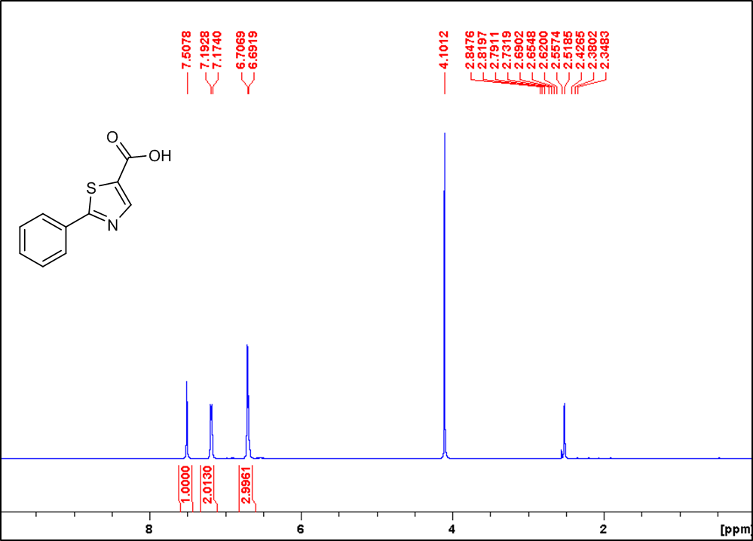

13C NMR of compound **XX** (ARW-220)

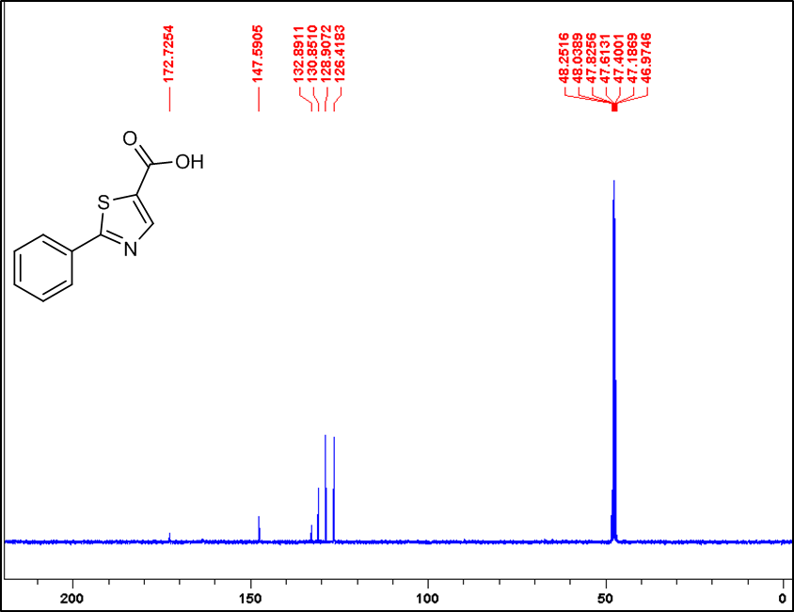

1H NMR of compound **23 (NJ1-87cont)**



13C NMR of compound **23 (NJ1-87cont)** 

1H NMR of compound **24 (NJ1-53)**



13C NMR of compound **24 (NJ1-53)**



1H NMR of compound **26 (NJ1-58)**

 

13C NMR of compound **26 (NJ1-58)**

 

1H NMR of compound **27 (NJ1-59)**

 

13C NMR of compound **27 (NJ1-59)**

 

1H NMR of compound **XX** (ARW-222)

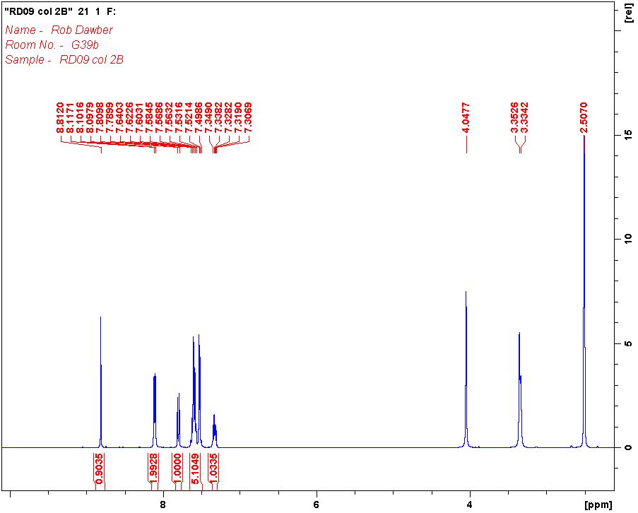

13C NMR of compound **XX** (ARW-222)

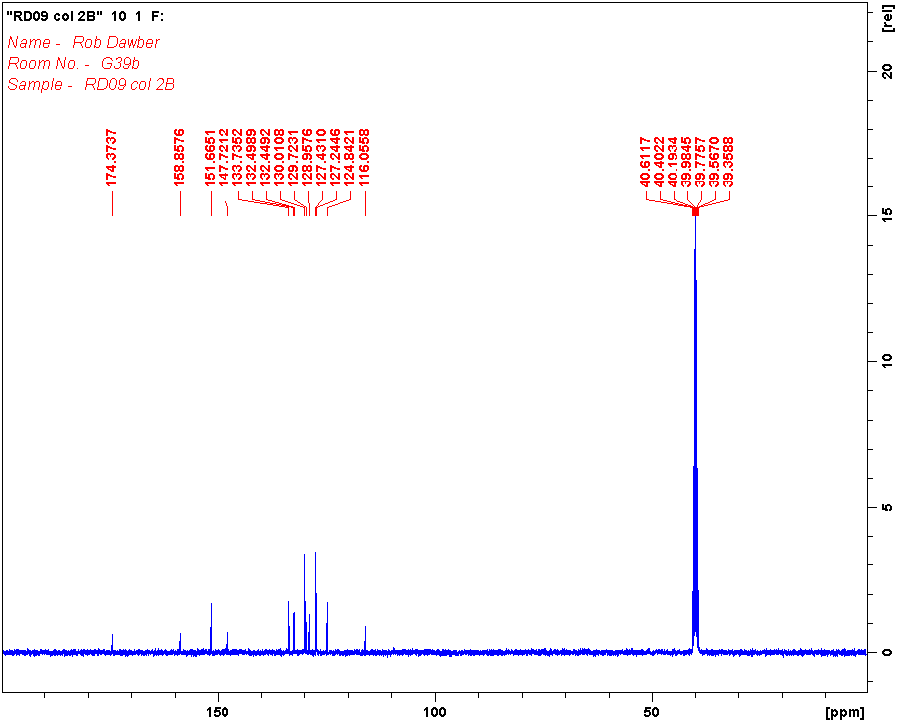

1H NMR of compound **28 (NJ1-71)**

 

13C NMR of compound **28 (NJ1-71)**

 

# **6. Aggregation data for 17, 26 and 27 (Figure S2)**

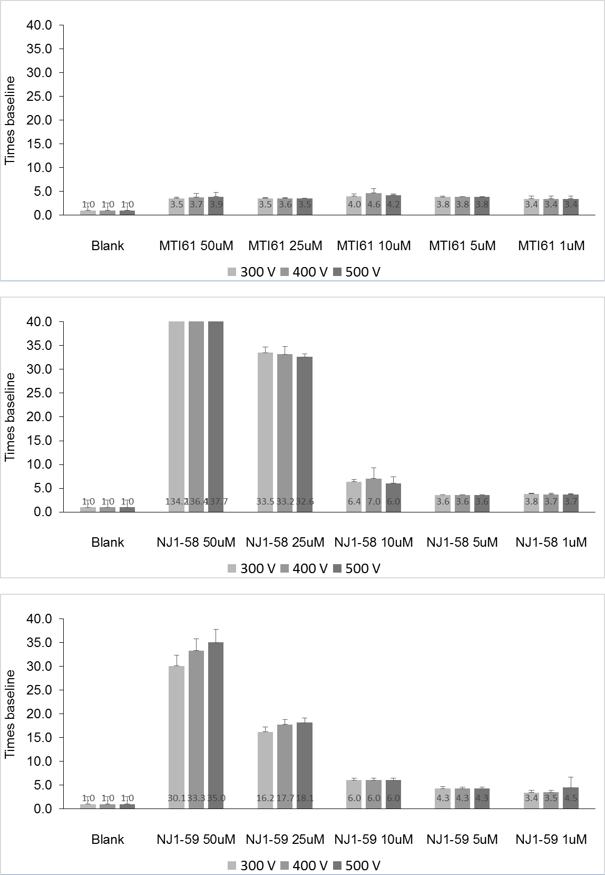

Figure S2. Aggregation data for compounds **17**, **26** and **27**. The data (measured in RNU *i.e.* relative nephelometric unit) is shown as the mean ± SD and normalized to the blank.

# **7. KNIME workflow**

KNIME workflow

# **X. References**

1. Grob (BMIDA)

# **STUFF**

## TmPPase inhibition curve (IC50 for the top 3 cpds: **MTI61**, **NJ1-58** and **NJ1-59**)

**NJ1-58**

LogIC50 = 0.8385 ± 0.02050 µM

IC50 = 6.89 ± 1.05 µM

**MTI61**

LogIC50 = 1.223 ± 0.01040 µM

IC50 = 16.69 ± 1.02 µM

## 

**NJ1-59**

LogIC50 = 0.9927 ± 0.03403 µM

IC50 = 9.83 ± 1.08 µM







## 5. Mass spectra for 5–15, 22–24 and 26–28

Compound **5** (NJ1-20)

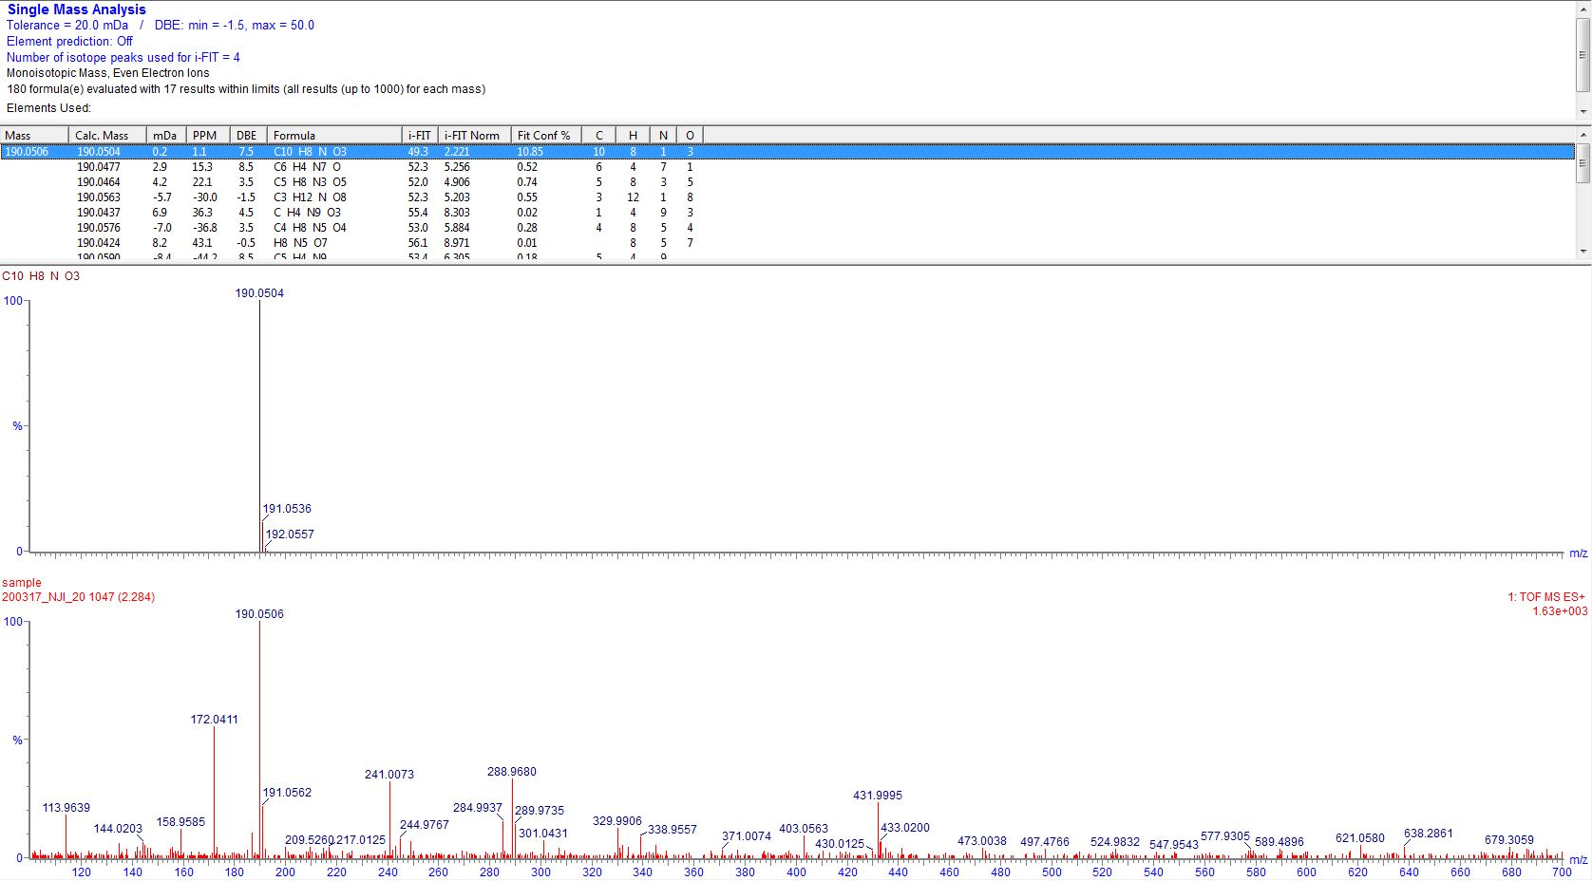

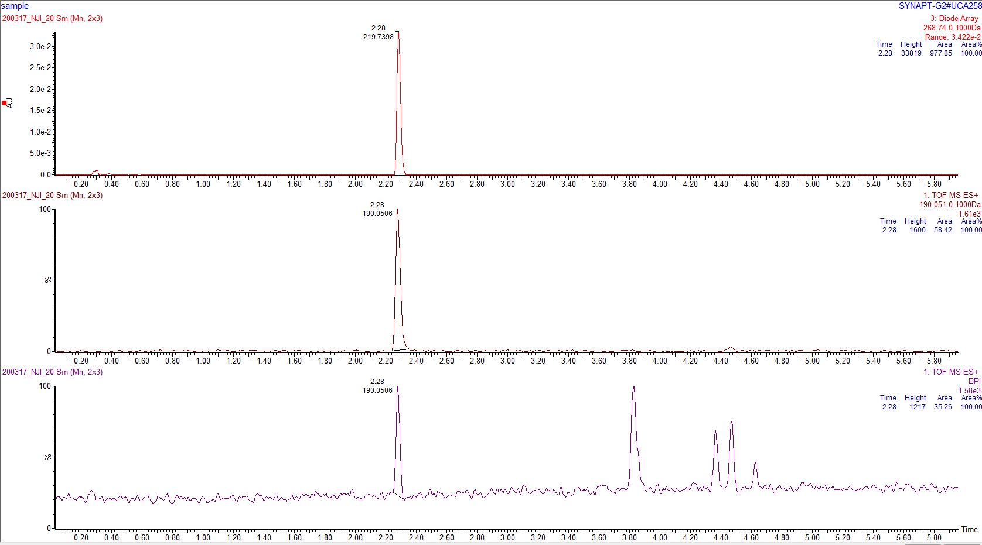

Compound **6** (NJ1-35)

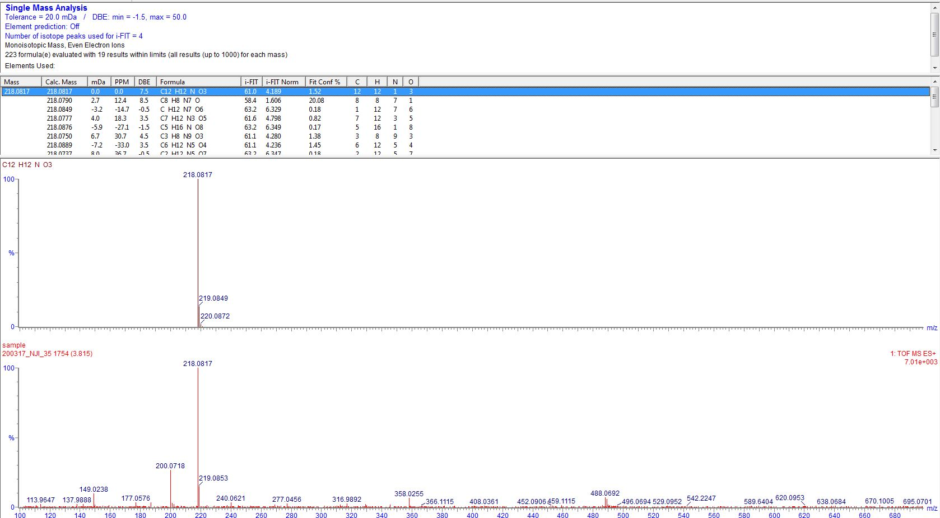

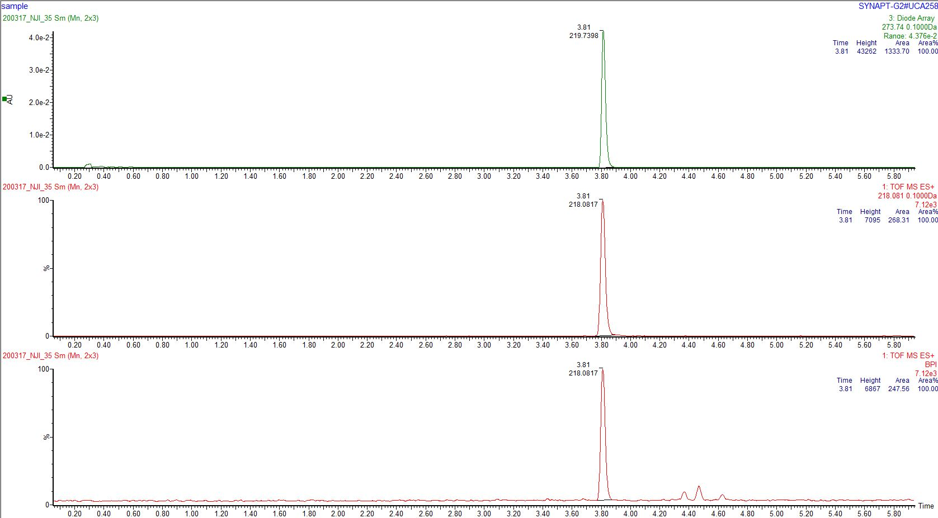

Compound **7** (DAP-06)

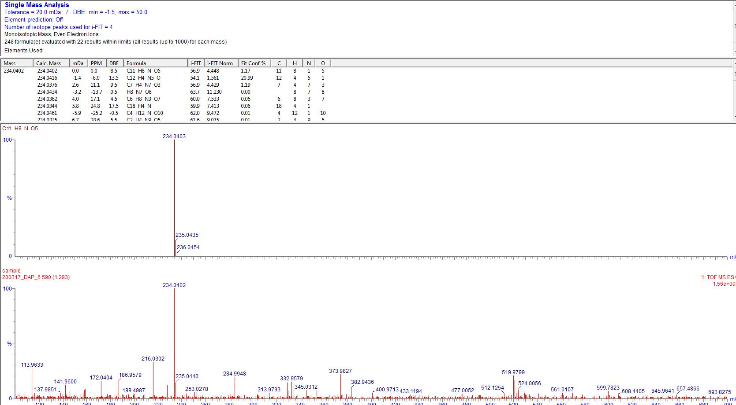

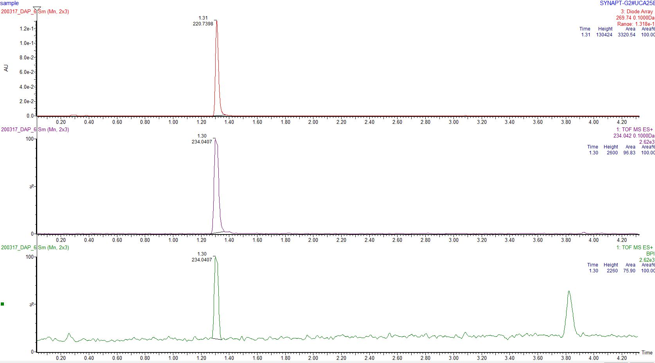

Compound **8** (NJ1-31)

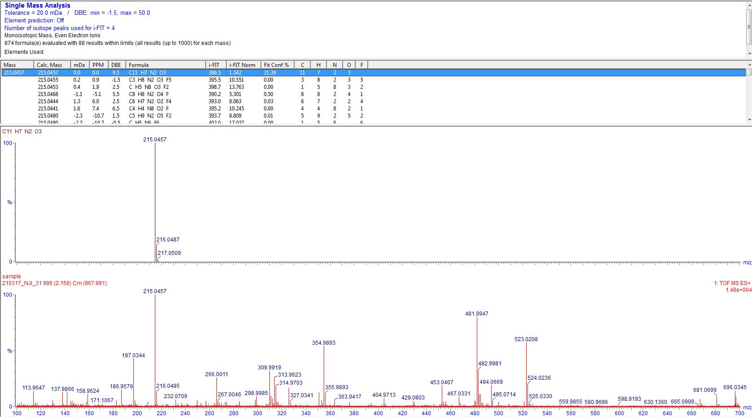

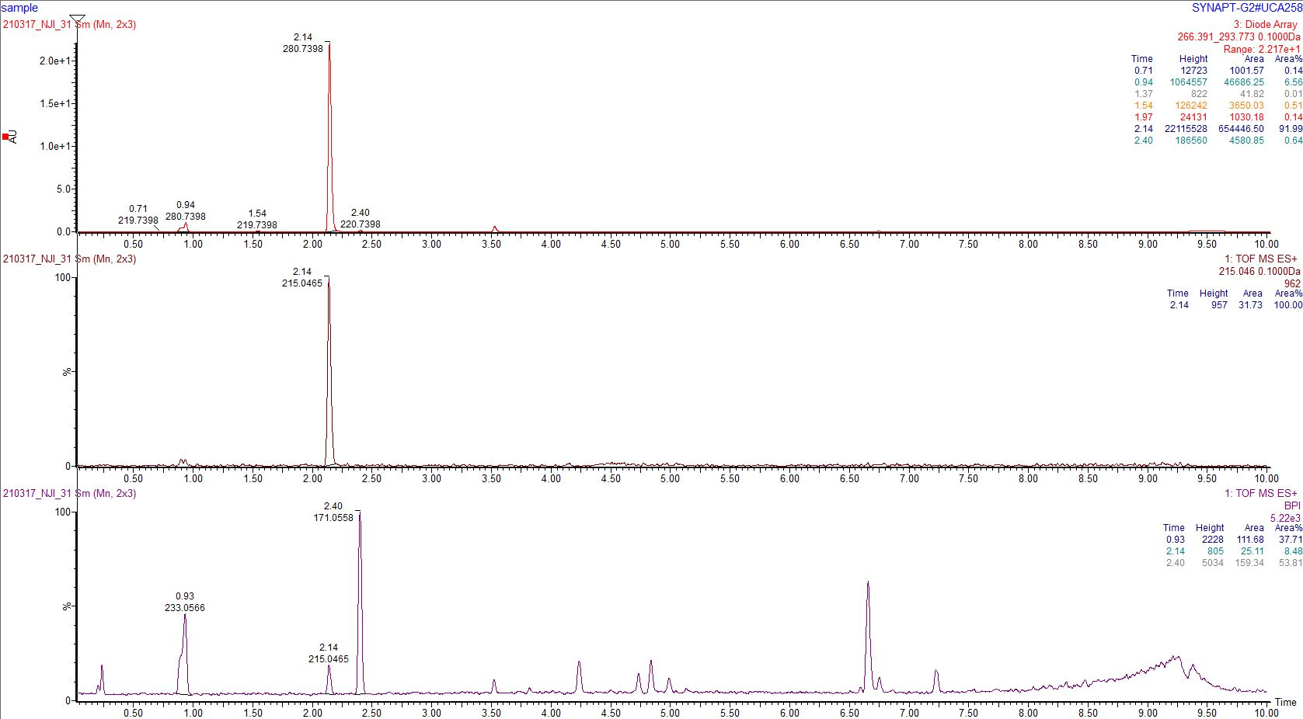

Compound **9** (NJ1-39)

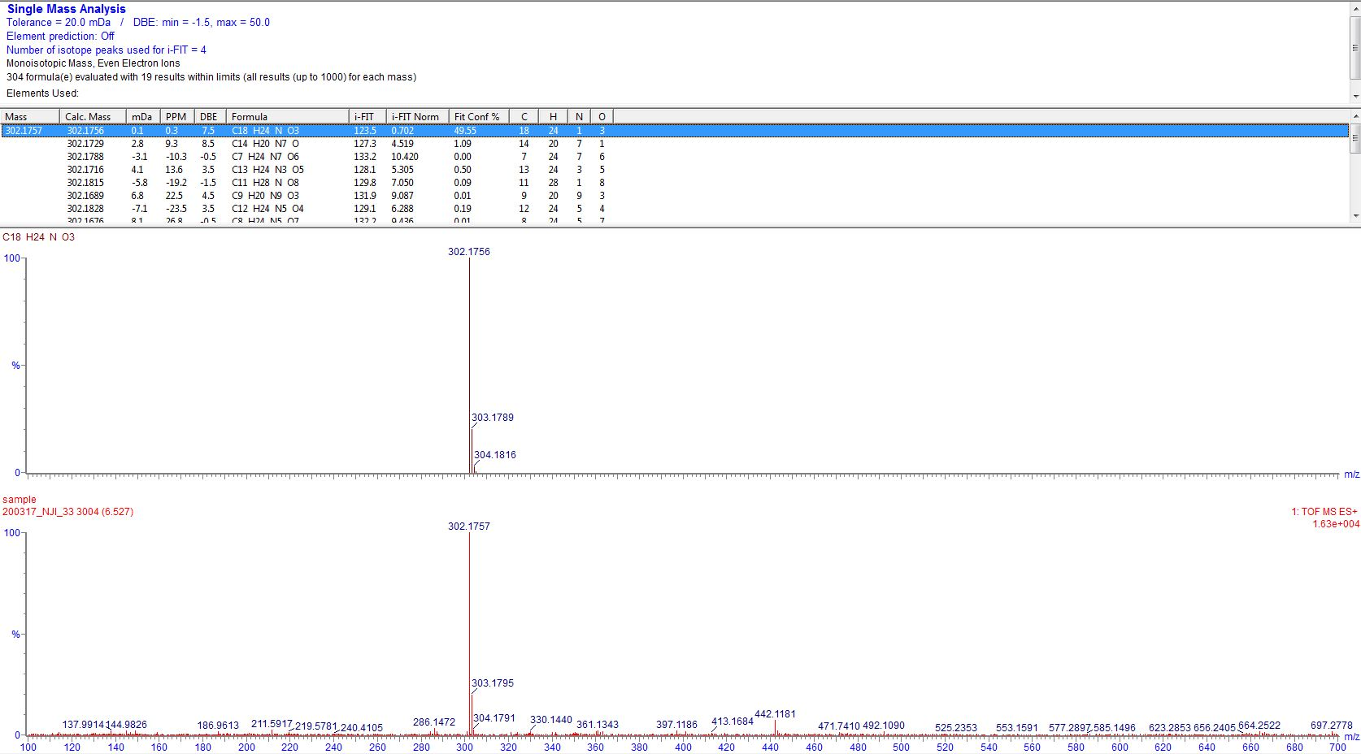

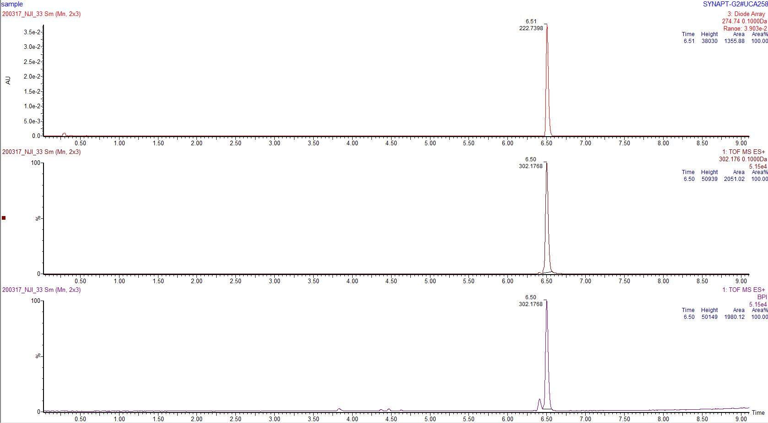

Compound **10** (NJ1-19)

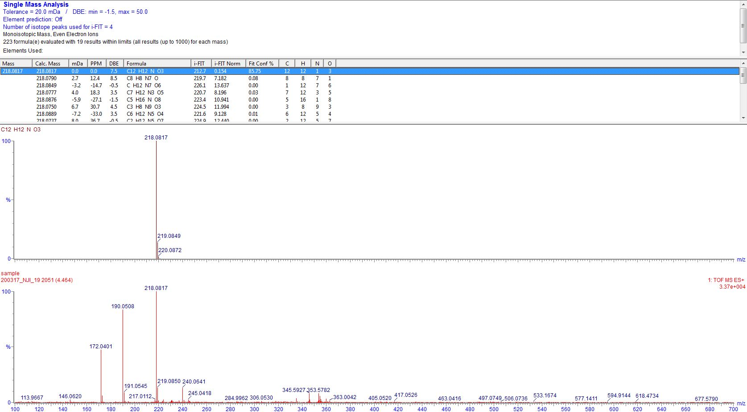

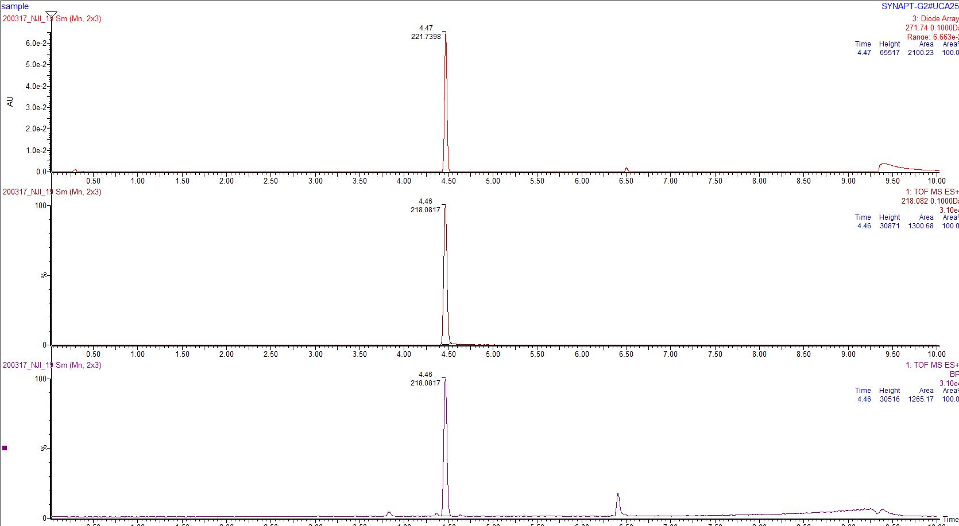

Compound **11** (DAP-16)

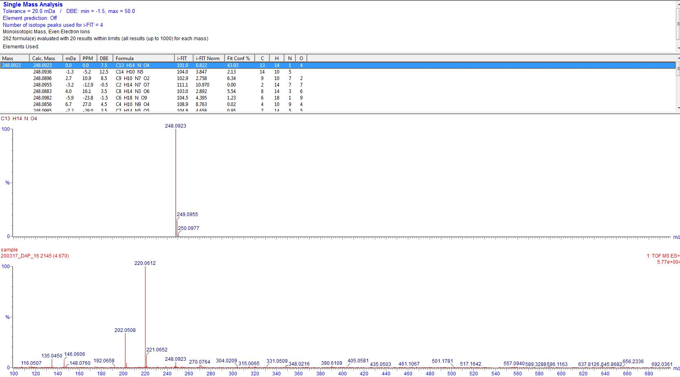

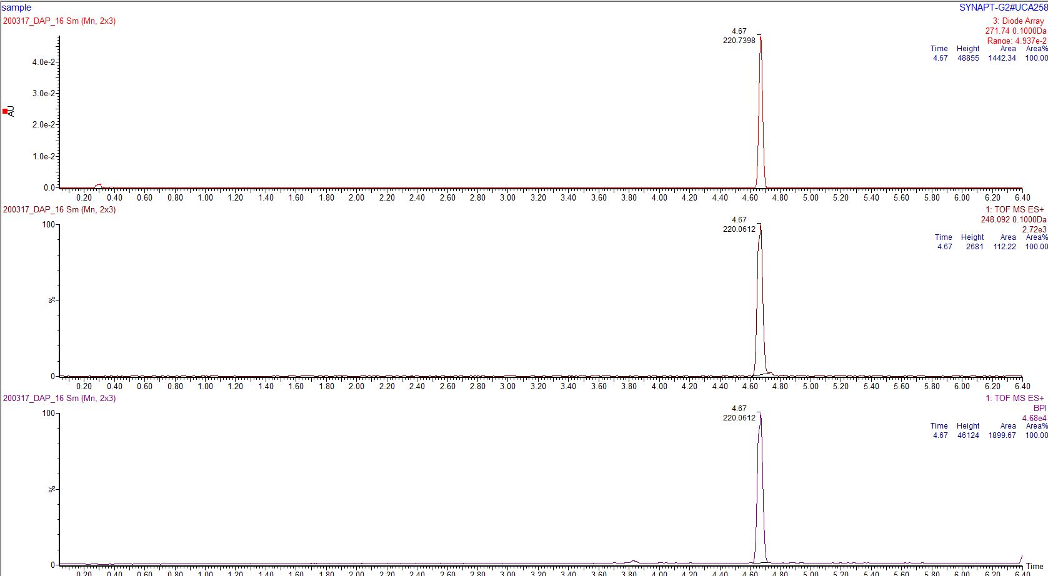

Compound **12** (DAP-10b)

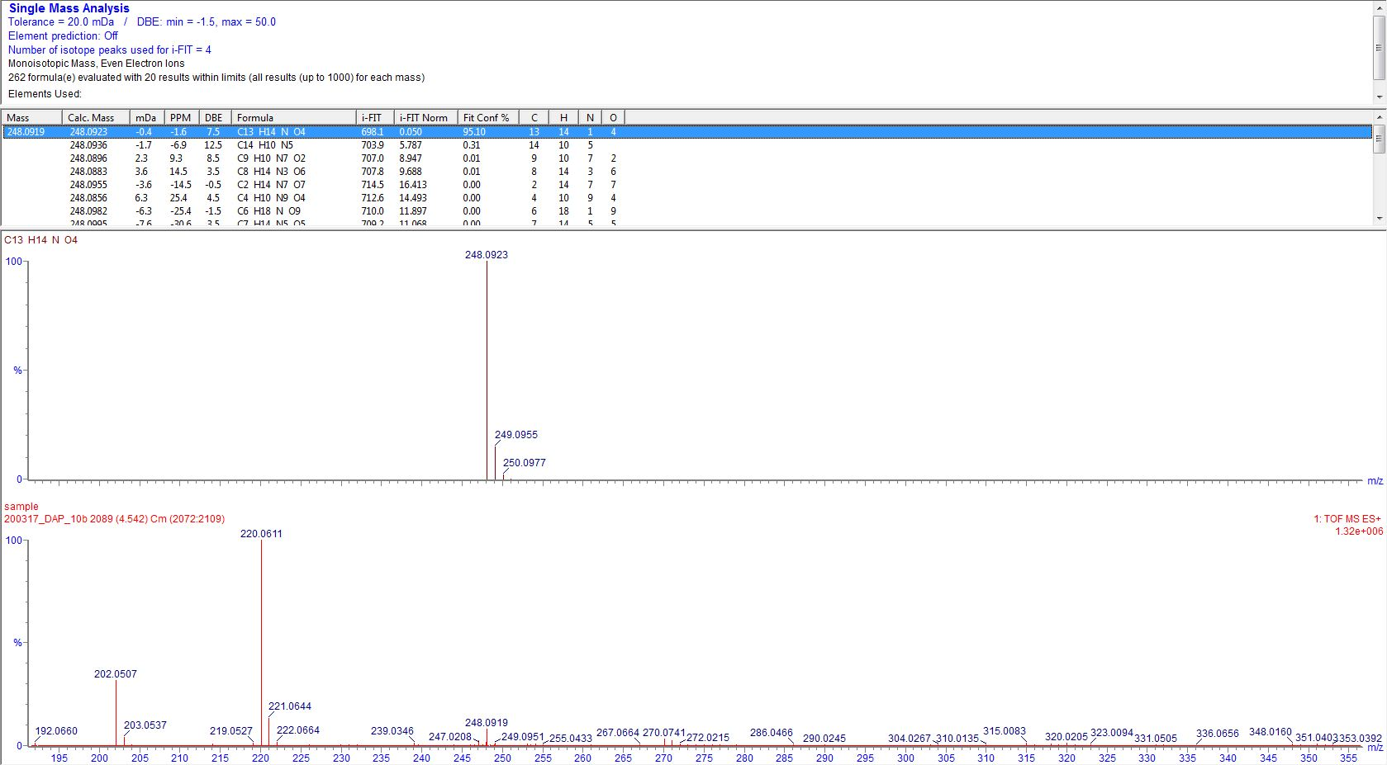

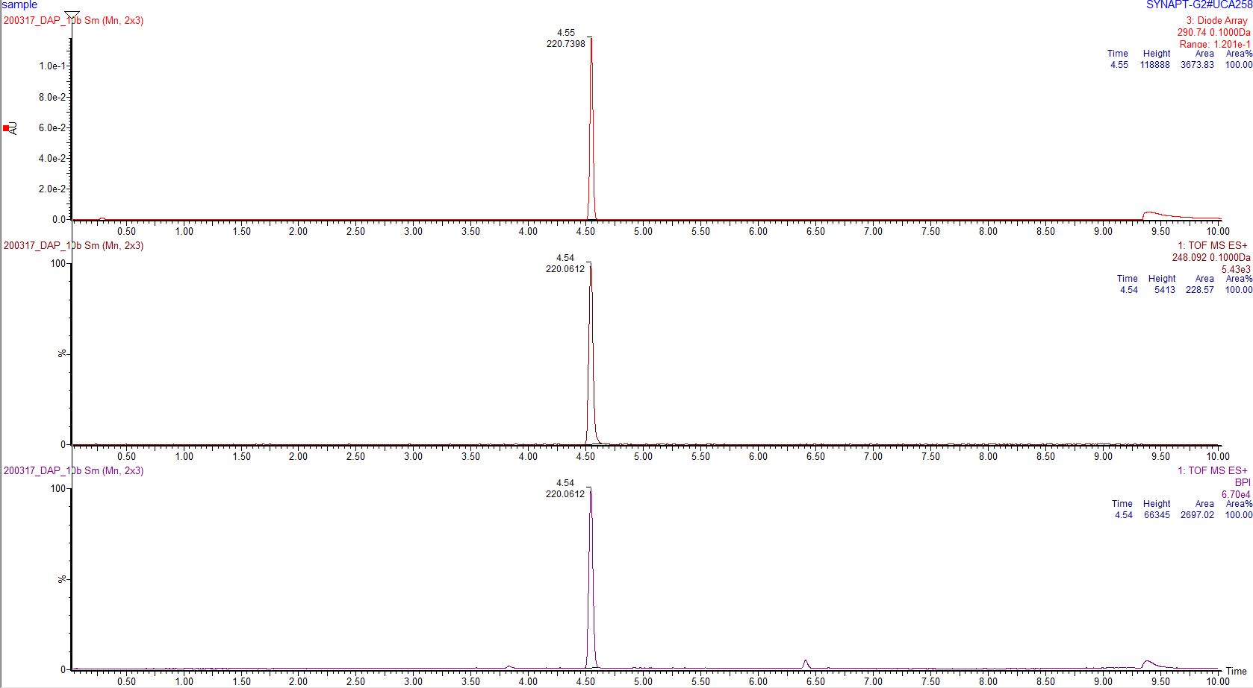

Compound **13** (NJ1-27)

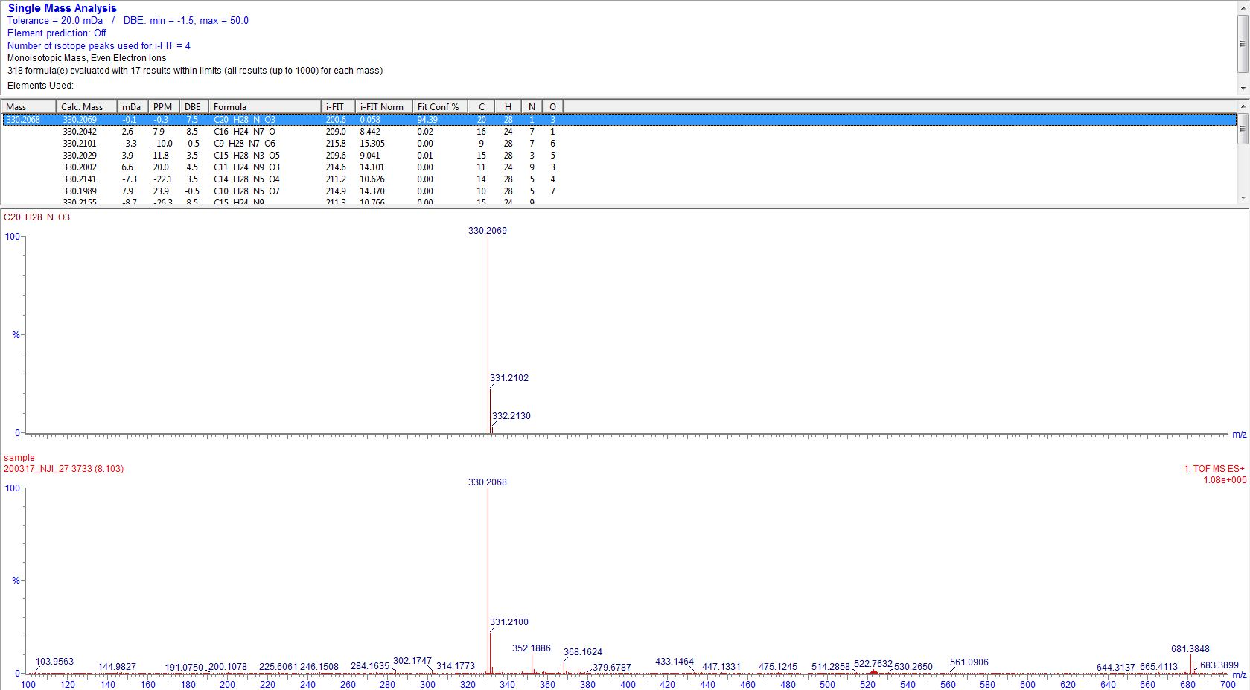

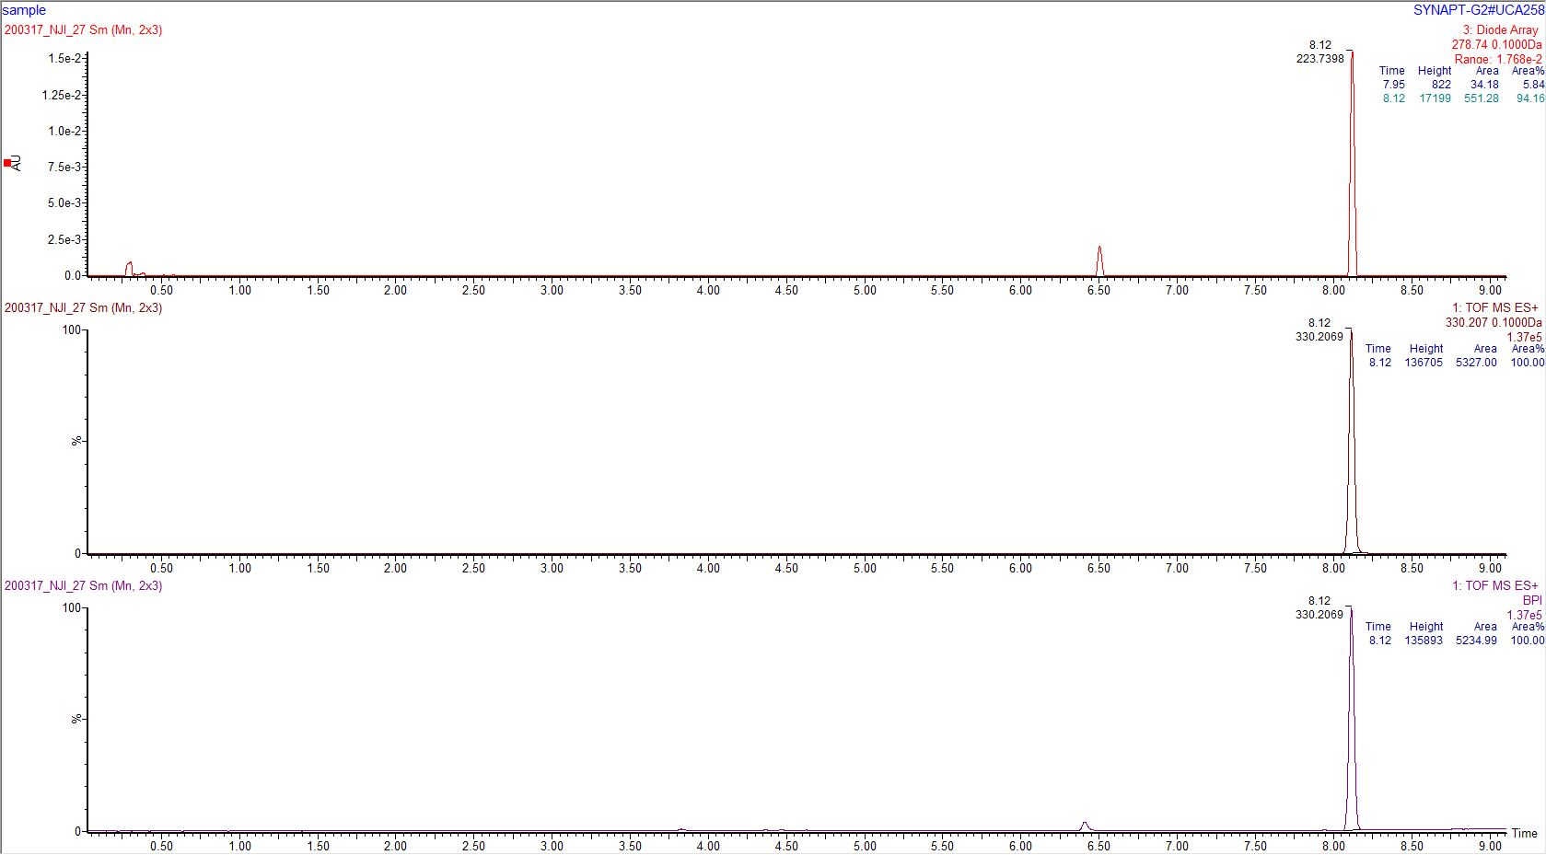

Compound **14** (NJ1-26)

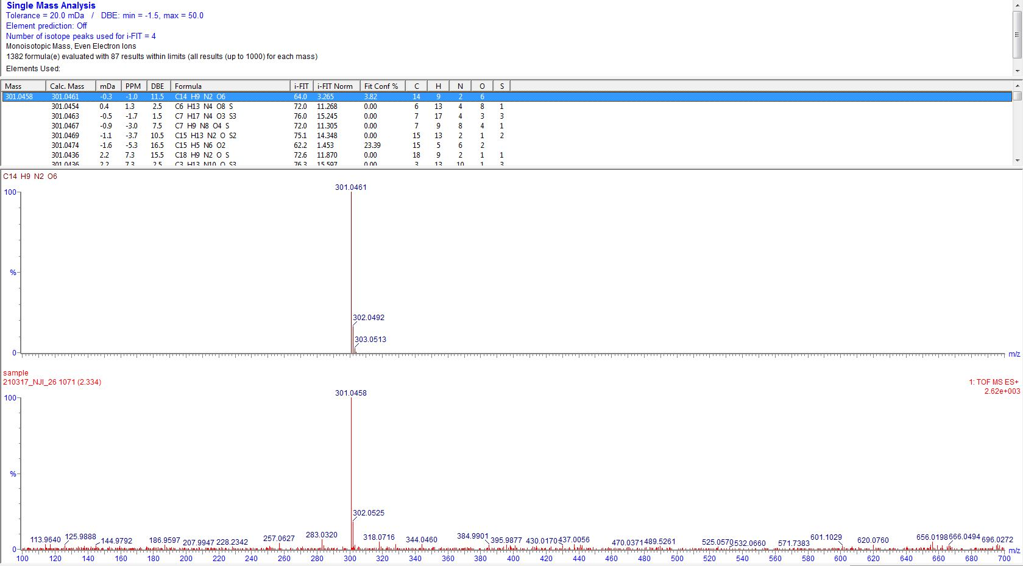

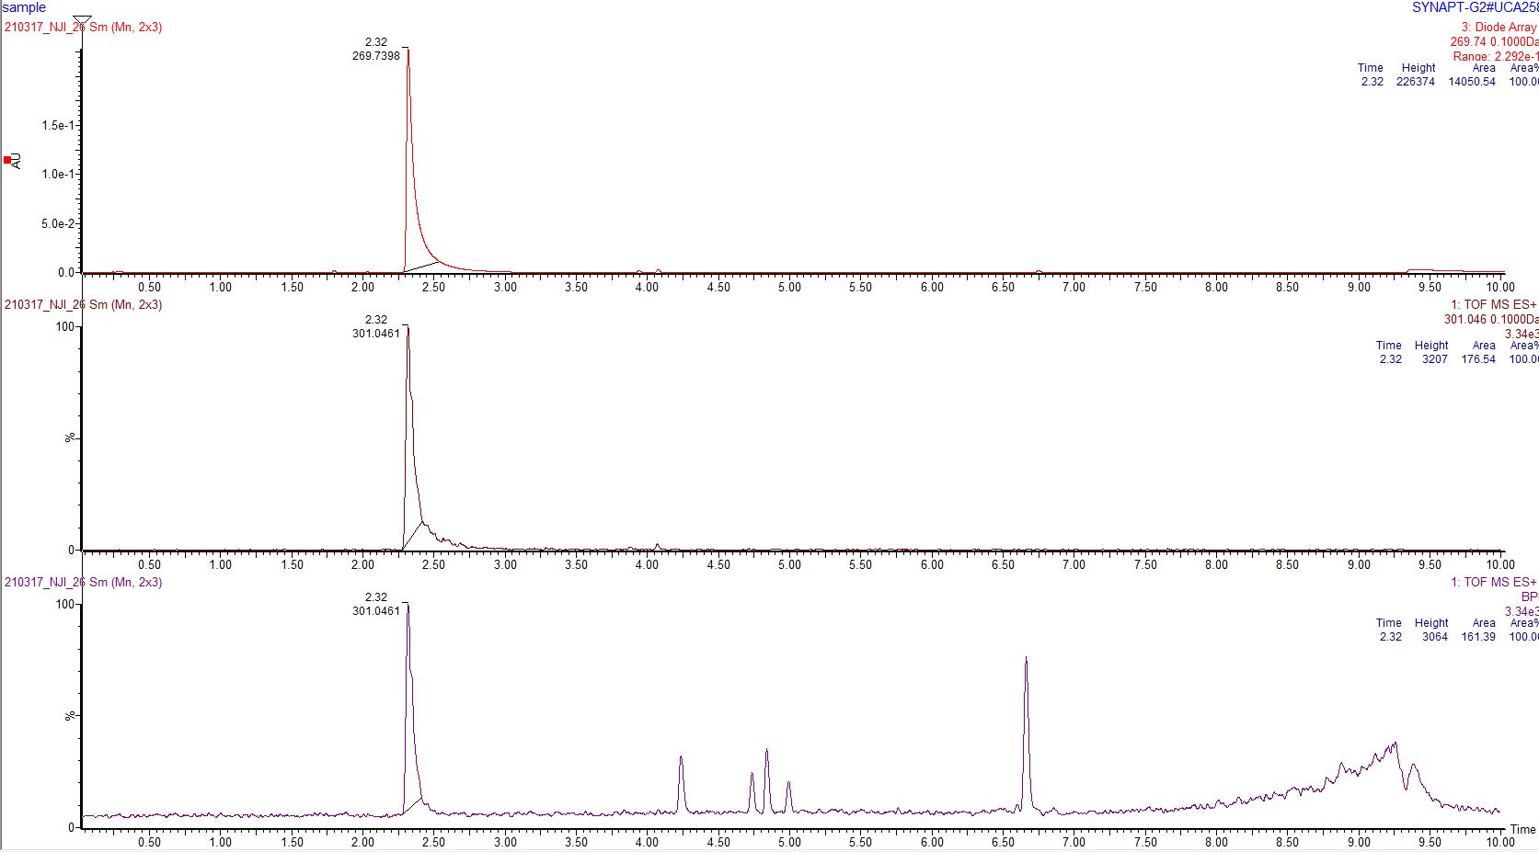

Compound **15** (NJ1-24)

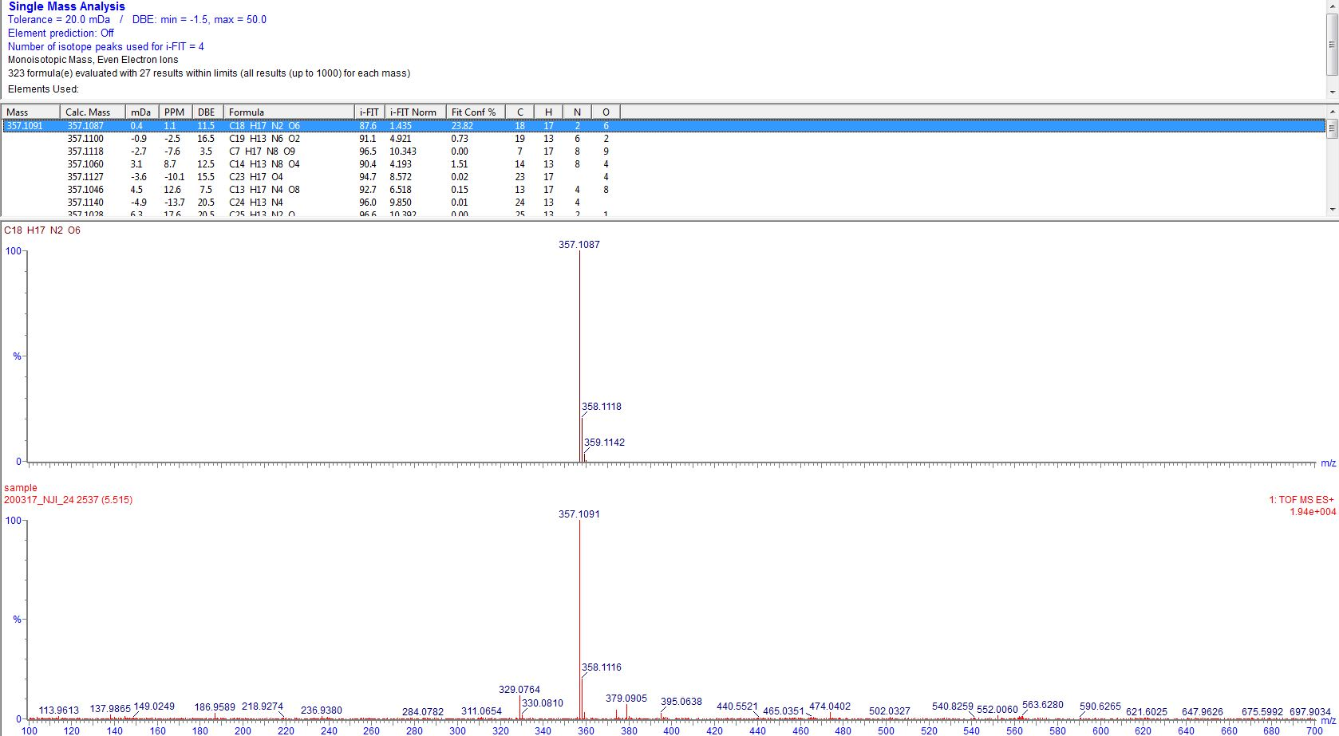

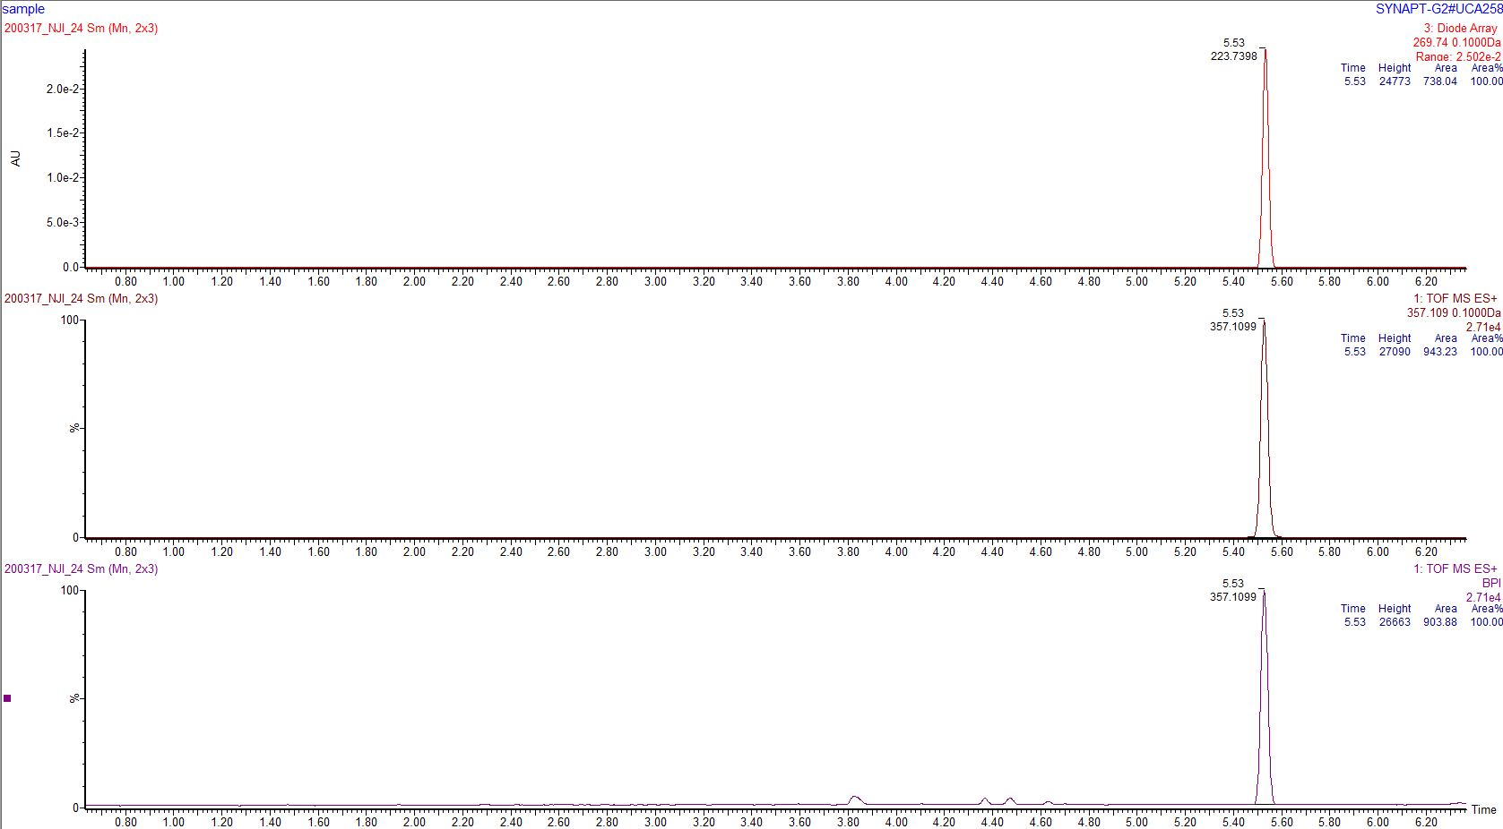

Compound **22** (NJ1-32)

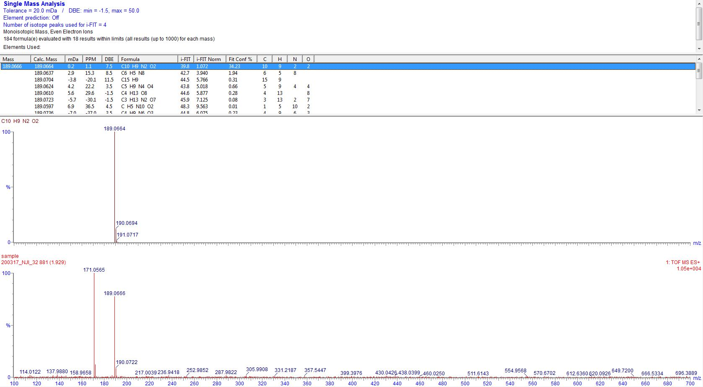

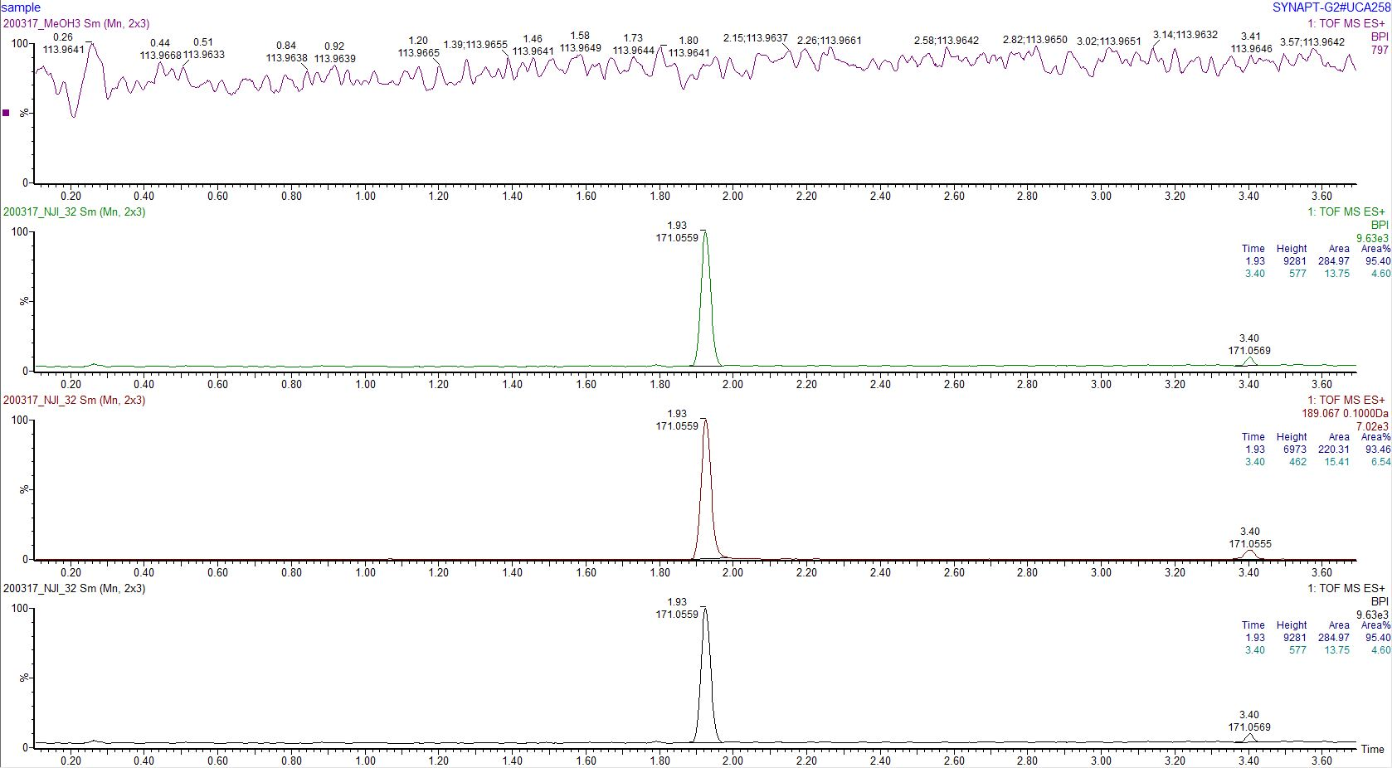

Compound **23** (NJ1-87cont)

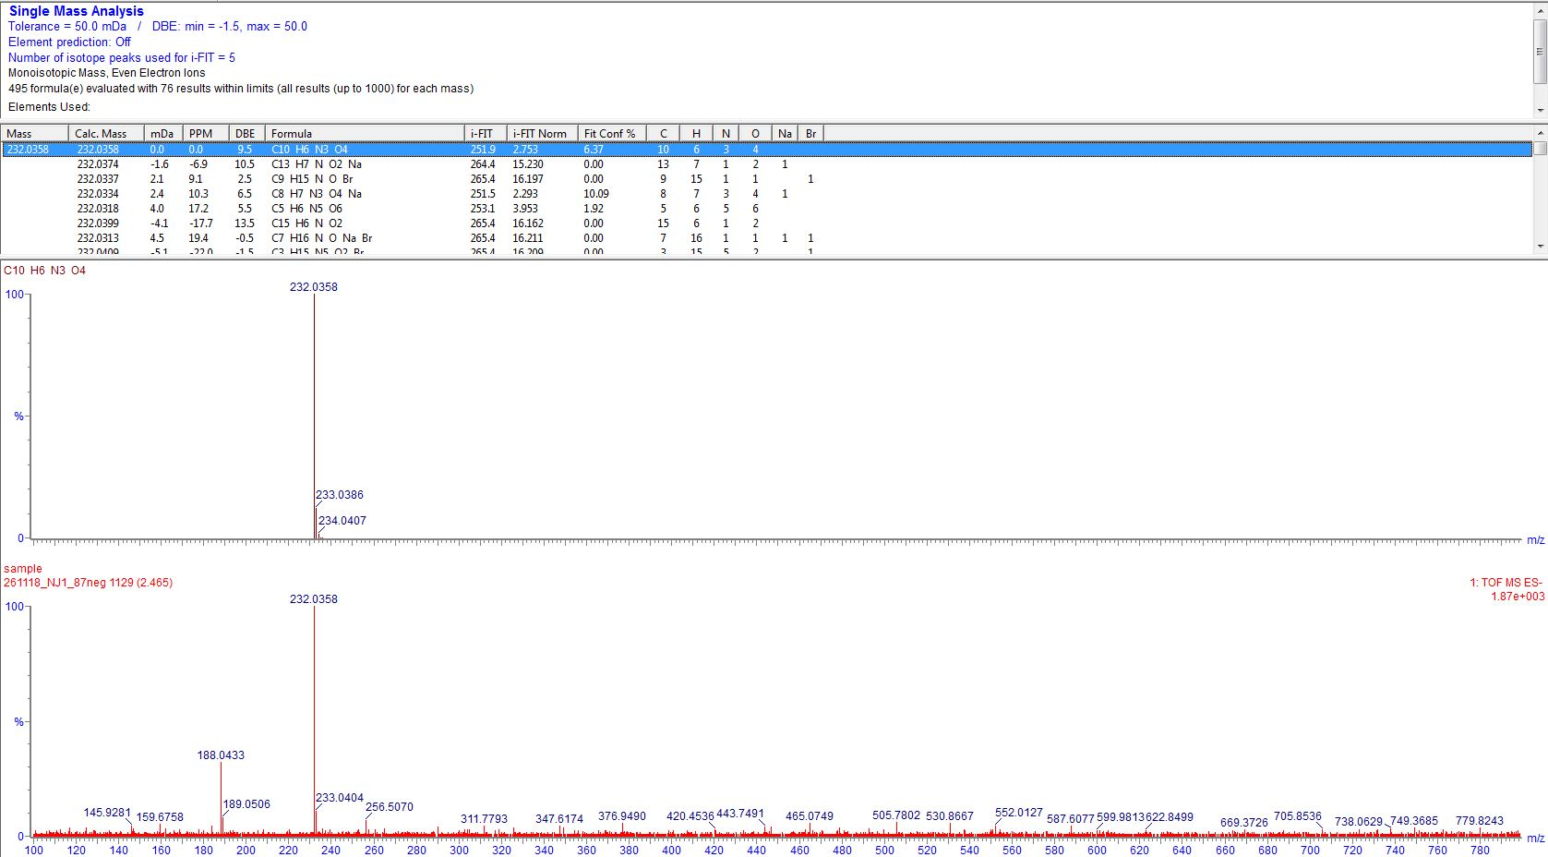

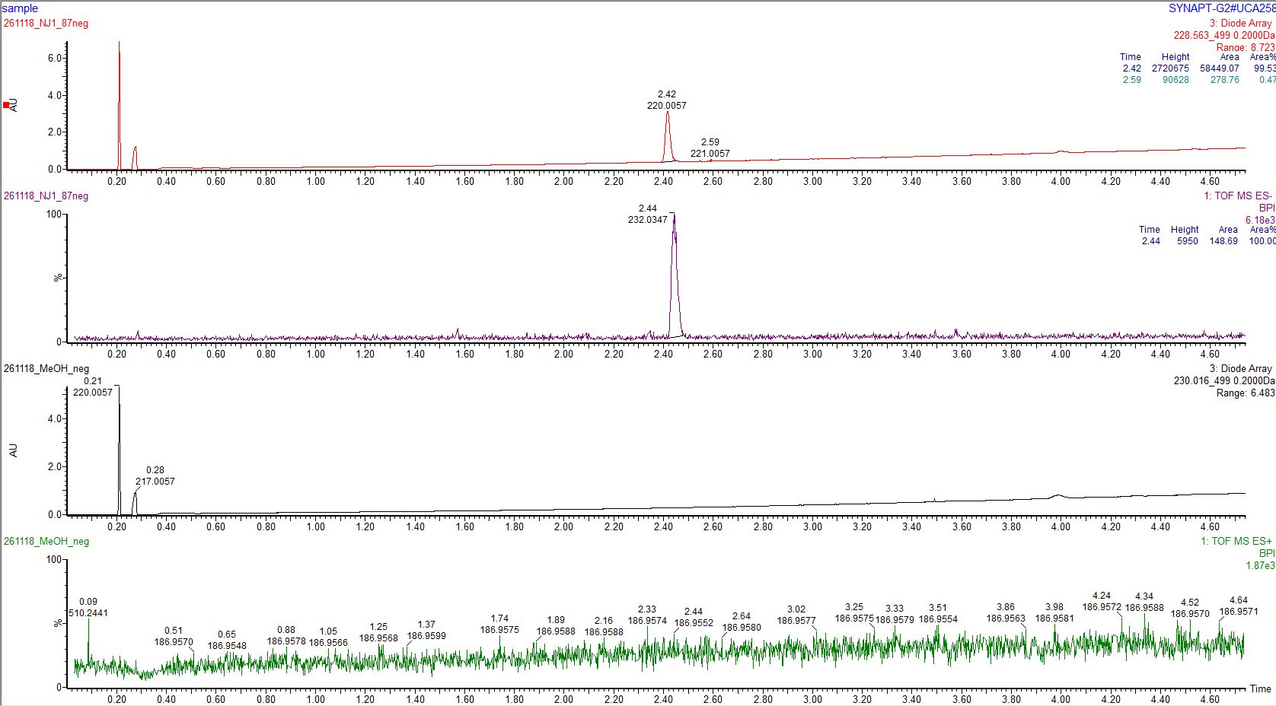

Compound **24** (NJ1-53)

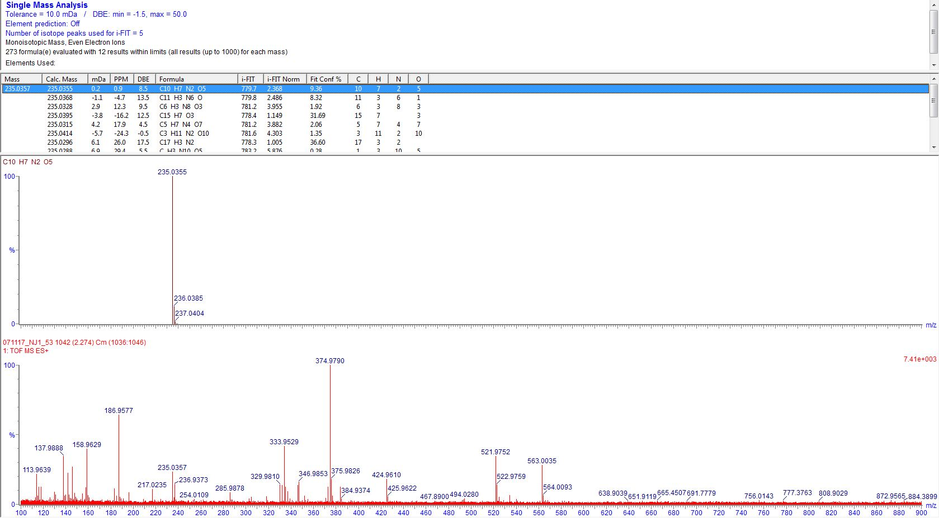

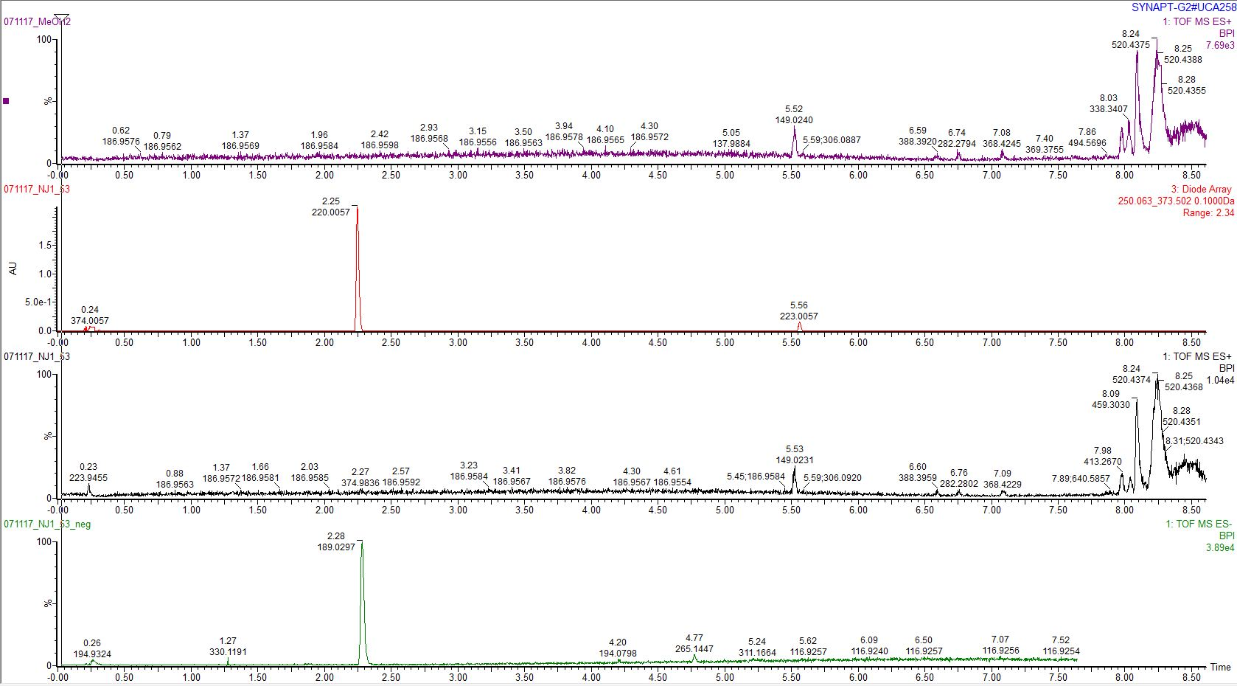

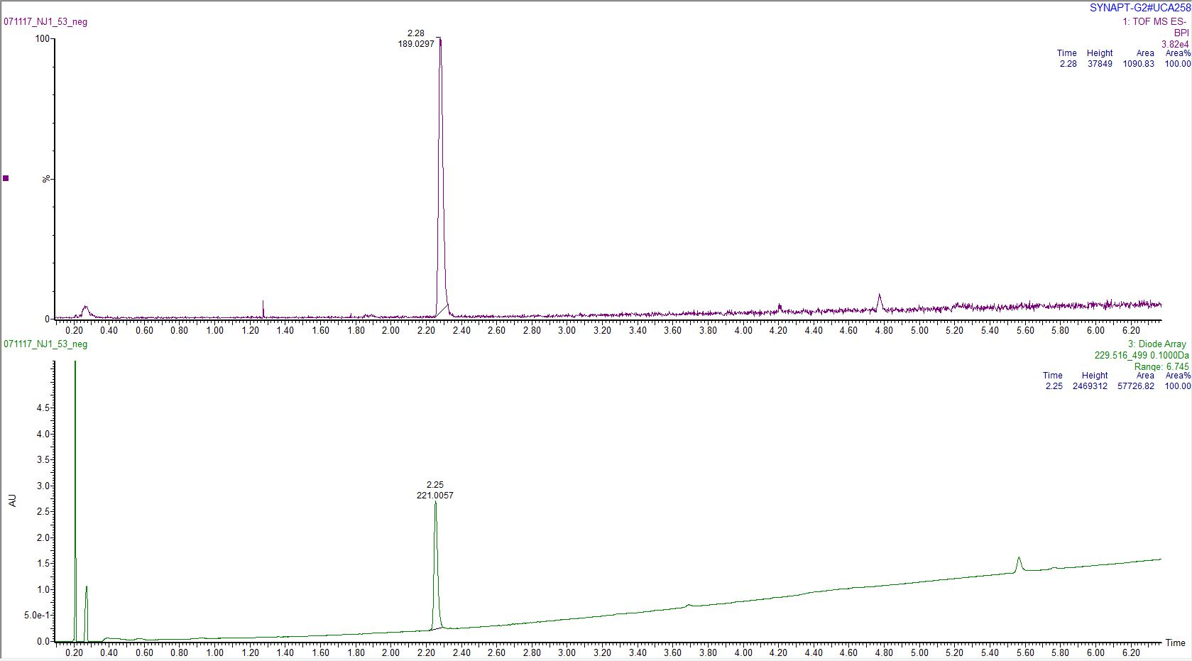

Compound **26** (NJ1-58)

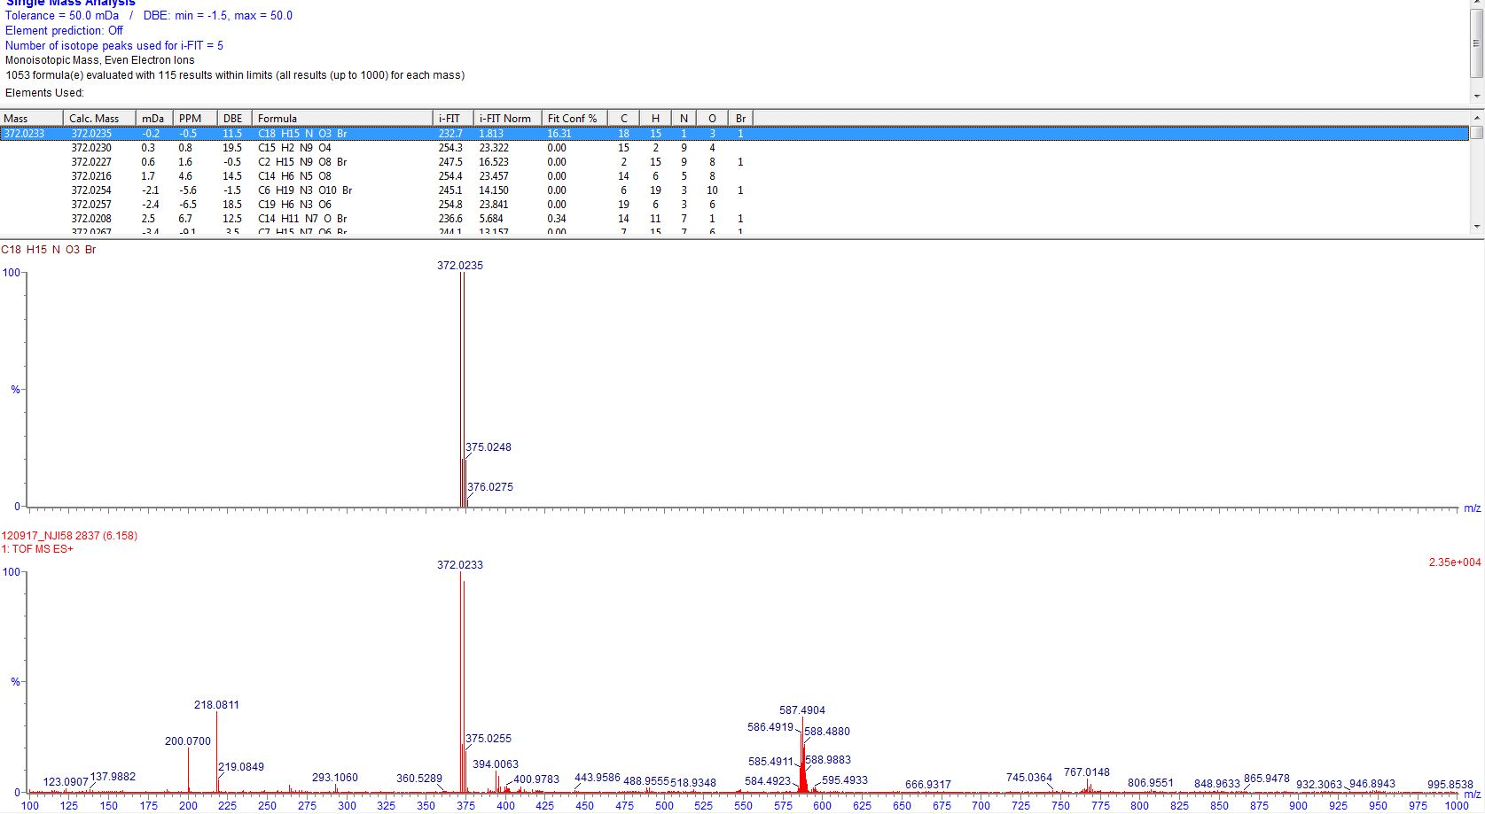

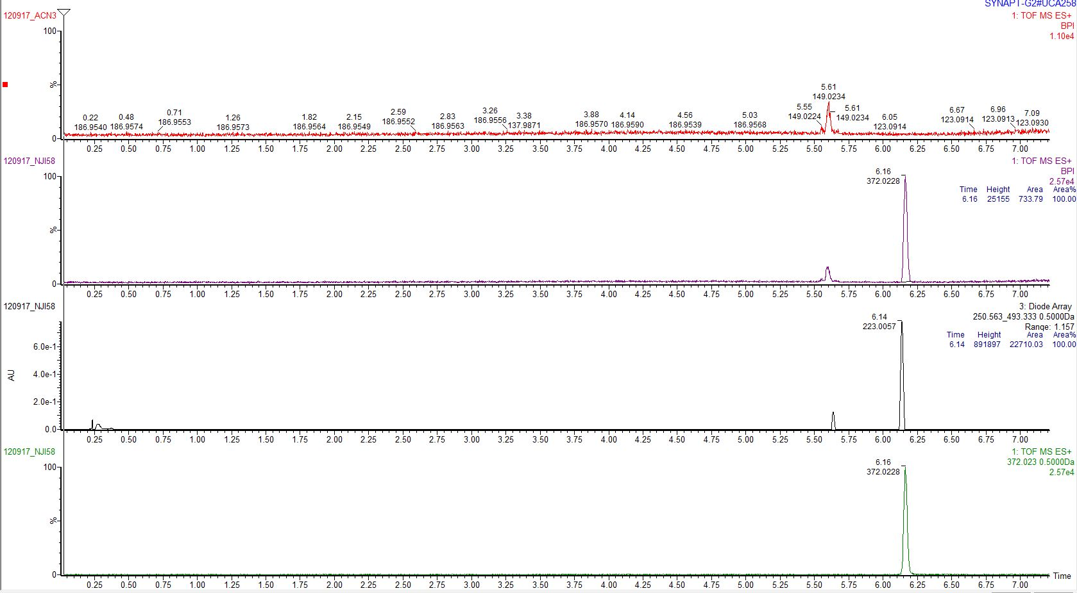

Compound **27** (NJ1-59)

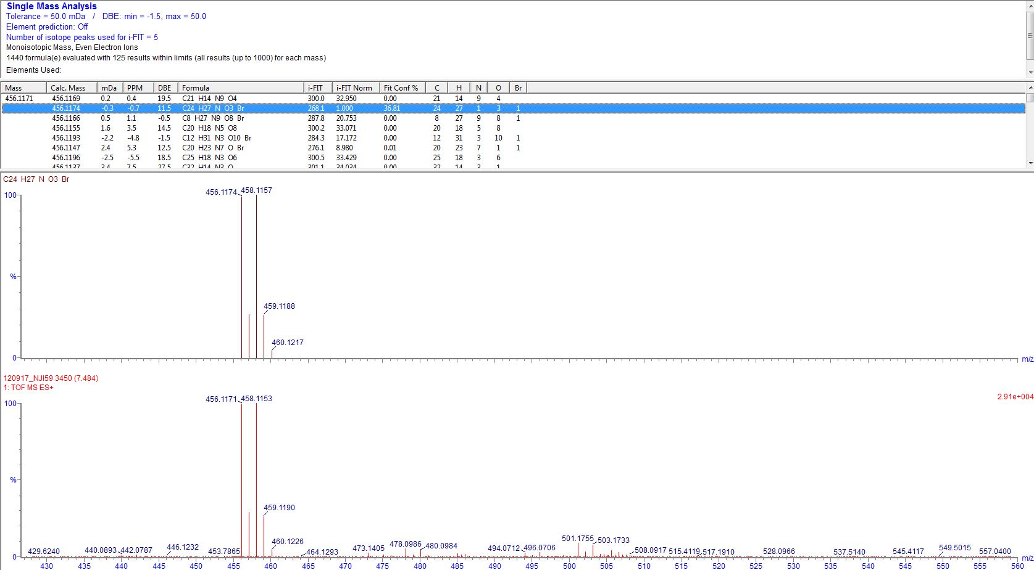

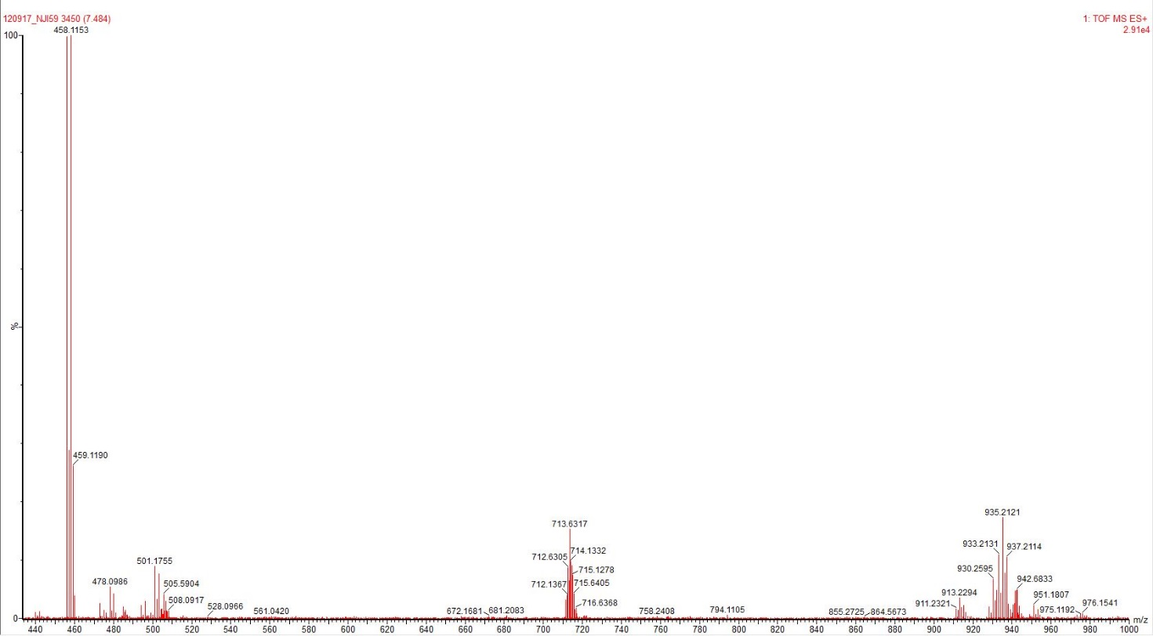

Compound **28** (NJ1-71)

R = *o*-COOH; *p*-COOH; 1,3-di-*tert*-butyl; 1,3-dimethyl + DIMER ACID/ESTER



Scheme SX. Alkyne route towards isoxazole 3-carboxylic acids

**Method A – General [3 + 2] cycloaddition procedure for the synthesis of compounds MTI-35, 55, 69, 73 and** **SM for MTI47 (ethynylboronic acid MIDA ester)**.

Ethyl-2-chloro-2-(hydroxymino)acetate (1.5–4 equiv), sodium bicarbonate (1.5–4 equiv) and alkyne (*if solid*, 1 equiv) were added to a 25 mL round-bottomed flask. Thereafter the flask was capped with a septum and filled with argon before anhydrous acetonitrile (10–20 mL) was added, followed by mono- or dialkyne (*if liquid*, 1 equiv). The mixture was magnetically stirred at room temperature for 80–136 hours. The resulting mixture was evaporated dry and subsequently purified by Biotage Isolera flash chromatography with TLC gradient estimation and a 10–25 g SNAP KP-Sil cartridge with hexane:ethyl acetate (1:0 → 0:1) as the eluent. This provided a yield of 57–100% of the obtained product as a whitish solid.

**General procedure for the synthesis of compounds XXX-YYY via Suzuki-Miyaura cross-coupling of MIDA-boronate functionalized isoxazoles**

R = *o*-COOH, *p*-NO2

**Suzuki–Miyaura cross-coupling of MIDA boronate-functionalized isoxazole**



Scheme SX. Coupling route towards isoxazole 3-carboxylic acids. N.B. The isoxazole MIDA boronate used in this step had been previously prepared according to the **ONESTEP procedure**.

**General hydrolysis of isoxazoles:**

A round-bottomed flask was loaded with the isoxazole ester (1 equiv) and lithium hydroxide (2–4 equiv), followed by the addition of ethanol and water (2:1). The mixture was magnetically stirred at room temperature for 1–24 hours. The mixture was diluted with water (XX mL) and depending on the water solubility of the salts of the substrates, the easily soluble ones were washed with EtOAc (XX mL), whereas the hardly water soluble salts were not, before acidification using 1 M hydrochloric acid. The formed precipitates were extracted from the aqueous phase with three XX mL portions of EtOAc, dried with Na2SO4, evaporated and the residue was dried *in vacuo* overnight.